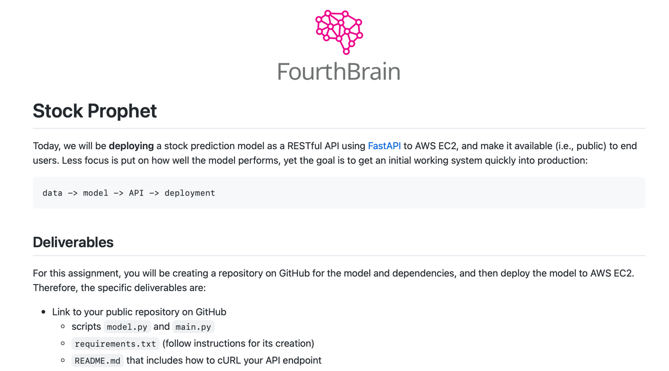

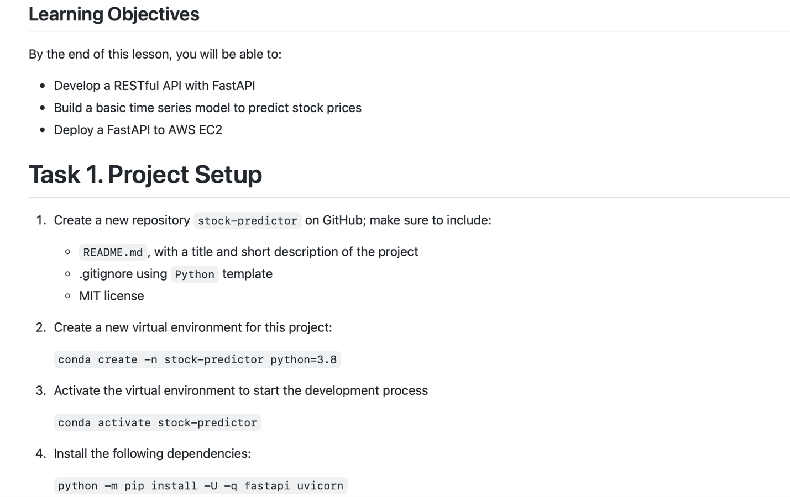

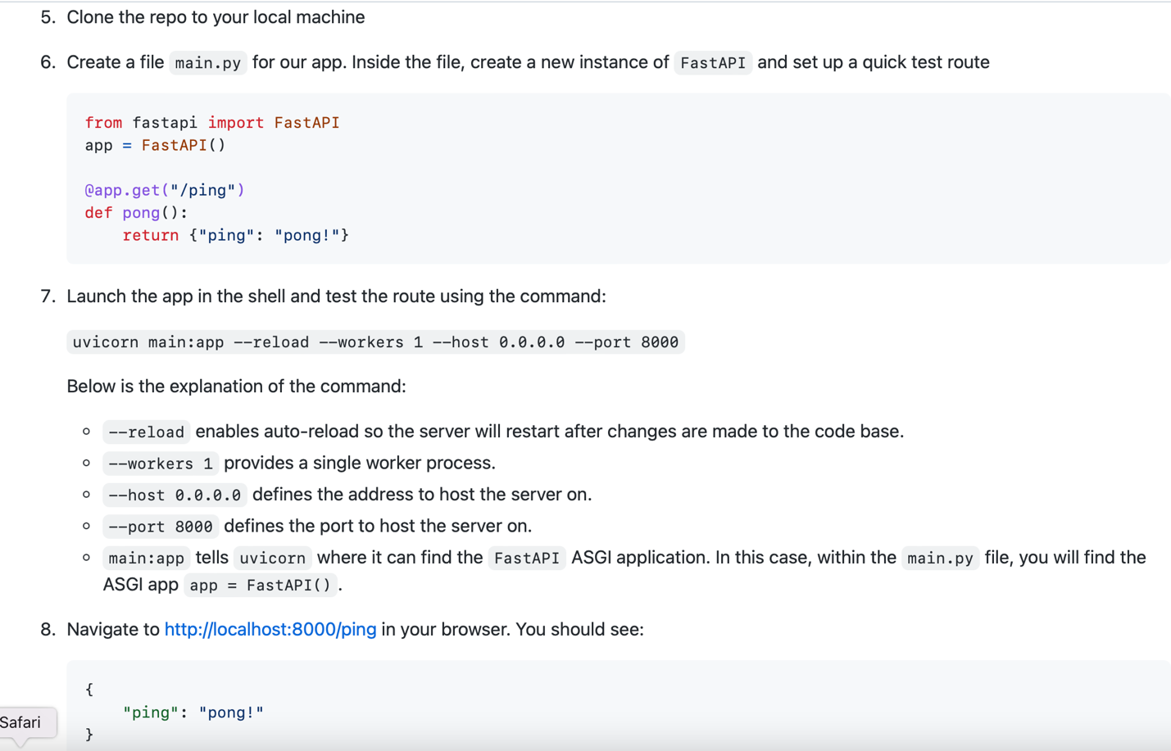

PART1: -1- repo

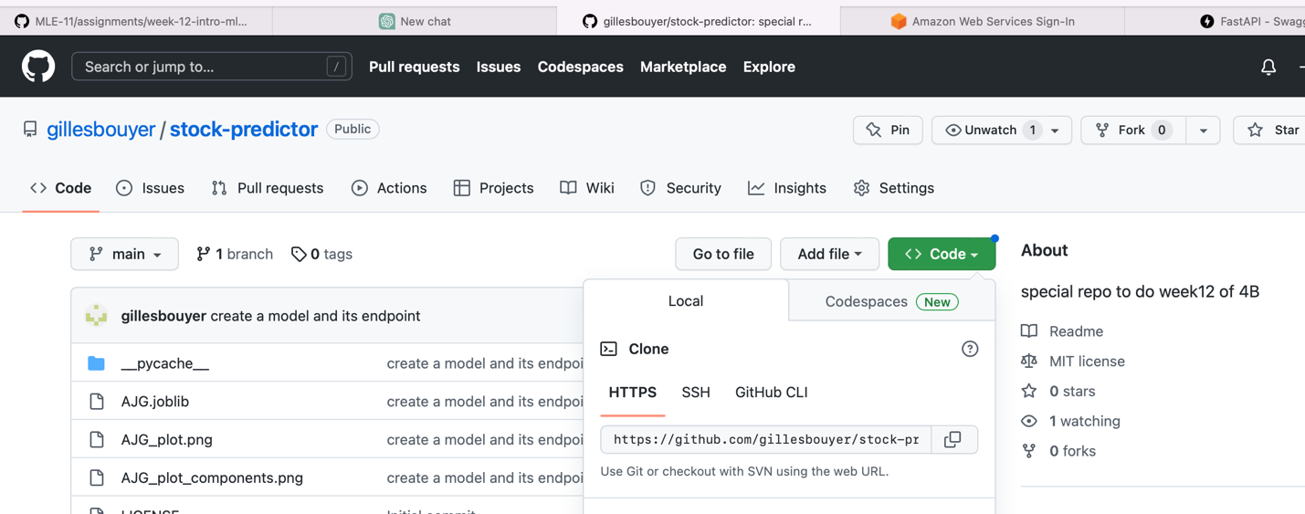

-2- conda create -n stock-predictor python=3.8

-3-&-4-7

(sa) Gilles@patricias-macbook-pro-2 ~ % conda deactivate

(base) Gilles@patricias-macbook-pro-2 ~ % conda activate stock-predictor

(stock-predictor) Gilles@patricias-macbook-pro-2 week12-AWS % uvicorn main:app --reload --workers 1 --host 0.0.0.0 --port 8001

INFO: Will watch for changes in these directories: ['/Users/Gilles/Documents/GitHub/week12-AWS']

INFO: Uvicorn running on http://0.0.0.0:8001 (Press CTRL+C to quit)

INFO: Started reloader process [15661] using StatReload

INFO: Started server process [15663]

INFO: Waiting for application startup.

INFO: Application startup complete.

INFO: 127.0.0.1:59295 - "GET /ping HTTP/1.1" 404 Not Found

INFO: 127.0.0.1:59297 - "GET /favicon.ico HTTP/1.1" 404 Not Found

WARNING: StatReload detected changes in 'main.py'. Reloading...

INFO: Shutting down

INFO: Waiting for application shutdown.

INFO: Application shutdown complete.

INFO: Finished server process [15663]

INFO: Started server process [15779]

INFO: Waiting for application startup.

INFO: Application startup complete.

INFO: 127.0.0.1:59450 - "POST /predict HTTP/1.1" 200 OK-5-

-5- CLONE THE REPO

git clone https://github.com/gillesbouyer/stock-predictor.git

Cloning into 'stock-predictor'...

remote: Enumerating objects: 4, done.

remote: Counting objects: 100% (4/4), done.

remote: Compressing objects: 100% (4/4), done.

remote: Total 4 (delta 0), reused 0 (delta 0), pack-reused 0

Receiving objects: 100% (4/4), done.

-6- Need a bunch of libraries to run main.py

pip install joblib

pip install pandas

pip install yfinance

pip install prophet

pip install plotly

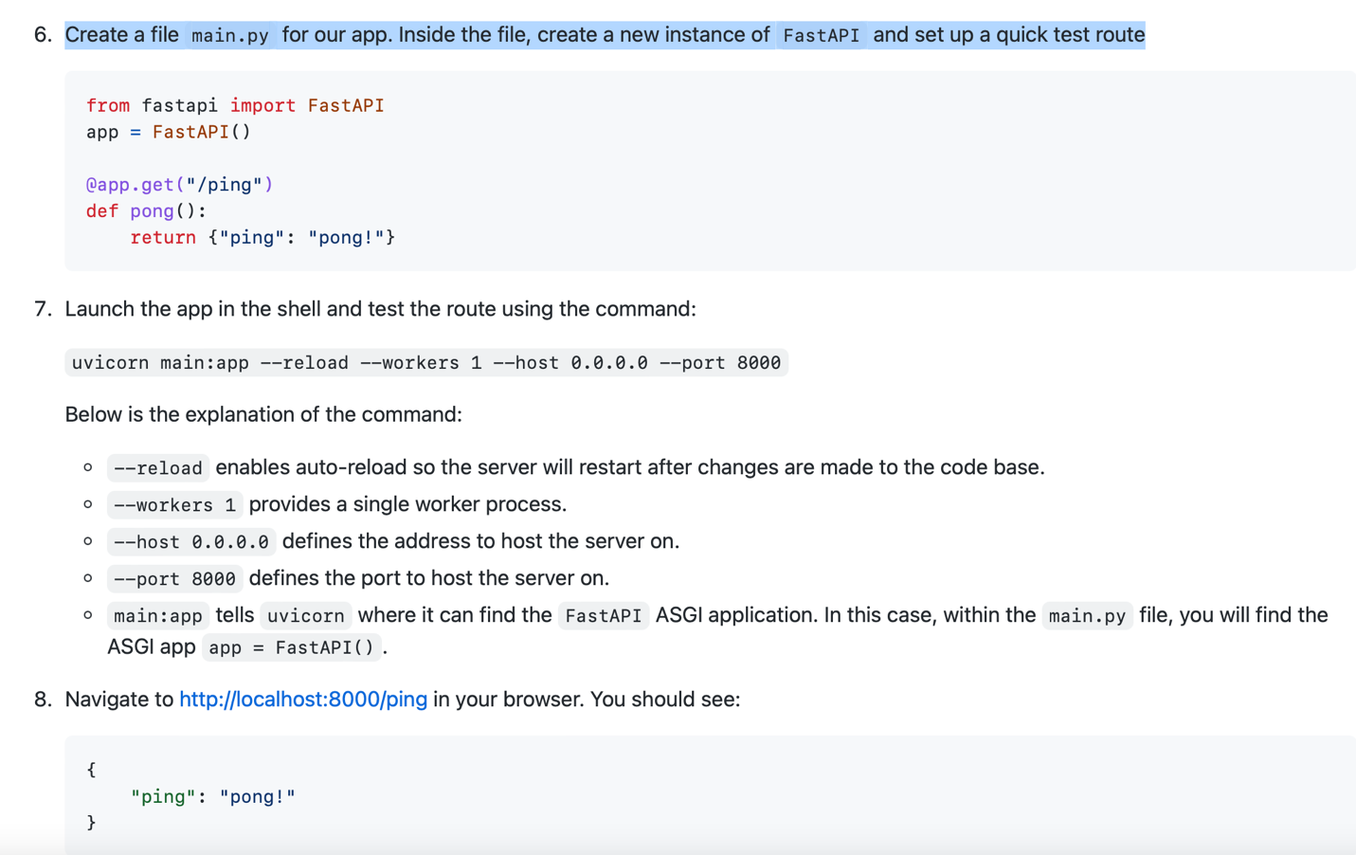

**PART2**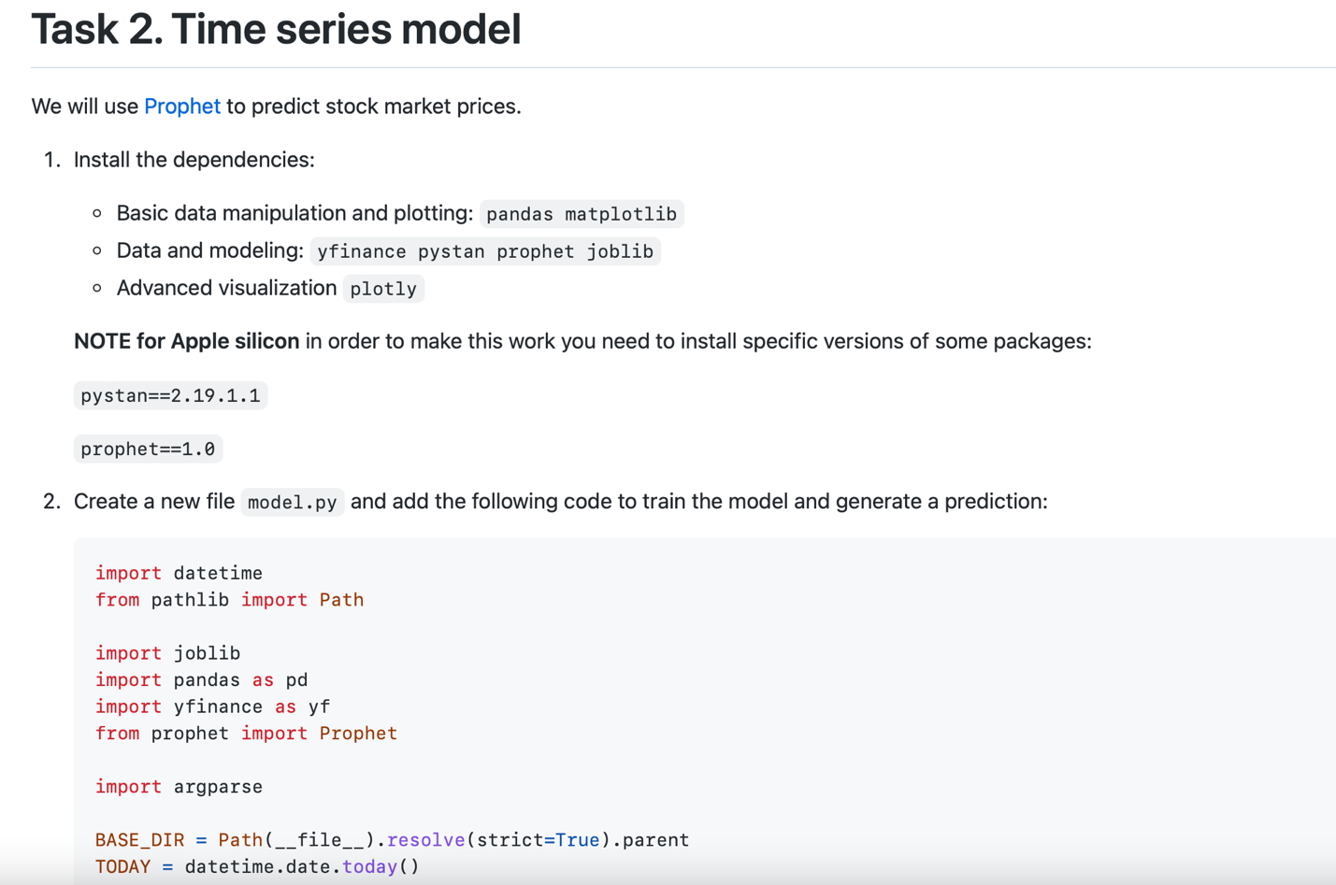

def train(ticker="MSFT"):

data = yf.download(ticker, "2020-01-01", TODAY.strftime("%Y-%m-%d"))

df_forecast = data.copy()

df_forecast.reset_index(inplace=True)

df_forecast["ds"] = df_forecast["Date"]

df_forecast["y"] = df_forecast["Adj Close"]

df_forecast = df_forecast[["ds", "y"]]

df_forecast

model = Prophet()

model.fit(df_forecast)

joblib.dump(model, Path(BASE_DIR).joinpath(f"{ticker}.joblib"))

def predict(ticker="MSFT", days=7):

model_file = Path(BASE_DIR).joinpath(f"{ticker}.joblib")

if not model_file.exists():

return False

model = joblib.load(model_file)

future = TODAY + datetime.timedelta(days=days)

dates = pd.date_range(start="2020-01-01", end=future.strftime("%m/%d/%Y"),)

df = pd.DataFrame({"ds": dates})

forecast = model.predict(df)

model.plot(forecast).savefig(f"{ticker}_plot.png")

model.plot_components(forecast).savefig(f"{ticker}_plot_components.png")

return forecast.tail(days).to_dict("records")

def convert(prediction_list):

output = {}

for data in prediction_list:

date = data["ds"].strftime("%m/%d/%Y")

output[date] = data["trend"]

return output

if __name__ == "__main__":

parser = argparse.ArgumentParser(description='Predict')

parser.add_argument('--ticker', type=str, default='MSFT', help='Stock Ticker')

parser.add_argument('--days', type=int, default=7, help='Number of days to predict')

args = parser.parse_args()

train(args.ticker)

prediction_list = predict(ticker=args.ticker, days=args.days)

output = convert(prediction_list)

print(output)

• Here we defined three functions (this model was developed by [Andrew Clark](https://twitter.com/aclarkdata1)):

1. train downloads historical stock data with [yfinance](https://github.com/ranaroussi/yfinance), creates a new Prophet model, fits the model to the stock data, and then serializes and saves the model as a [Joblib file](https://joblib.readthedocs.io/en/latest/generated/joblib.dump.html).
2. predict loads and deserializes the saved model, generates a new forecast, creates images of the forecast plot and forecast components, and returns the days included in the forecast as a list of dicts.
3. convert takes the list of dicts from predict and outputs a dict of dates and forecasted values; e.g., {"07/02/2020": 200}).
4. The last block of code allows you to execute the model from the command line, with two arguments, a valid stock ticker and the number of days to predict.

• Let's run it and see the results. In a shell, run:

python model.py

Output shall looks similar to the following (the output was generated in the late afternoon on July 19, 2022)

[*********************100%***********************] 1 of 1 completed

15:30:36 - cmdstanpy - INFO - Chain [1] start processing

15:30:36 - cmdstanpy - INFO - Chain [1] done processing

{'07/20/2022': 254.67755986604763, '07/21/2022': 254.3739109884936, '07/22/2022': 254.0702621109396, '07/23/2022': 253.7666132333857, '07/24/2022': 253.46296435583167, '07/25/2022': 253.15931547827768, '07/26/2022': 252.8556666007237}

15:30:38 - cmdstanpy - INFO - deleting tmpfiles dir: /var/folders/dk/5zskzghd2wl17_jf1yl86hh80000gn/T/tmpzwrmagib

15:30:38 - cmdstanpy - INFO - done

{

'07/20/2022': 254.67755986604763,

'07/21/2022': 254.3739109884936,

'07/22/2022': 254.0702621109396,

'07/23/2022': 253.7666132333857,

'07/24/2022': 253.46296435583167,

'07/25/2022': 253.15931547827768,

'07/26/2022': 252.8556666007237

}

are the predicted prices for the next 7 days for the Microsoft stock (ticker: MSFT).

Take note that the saved MSFT.joblib model along with two images

[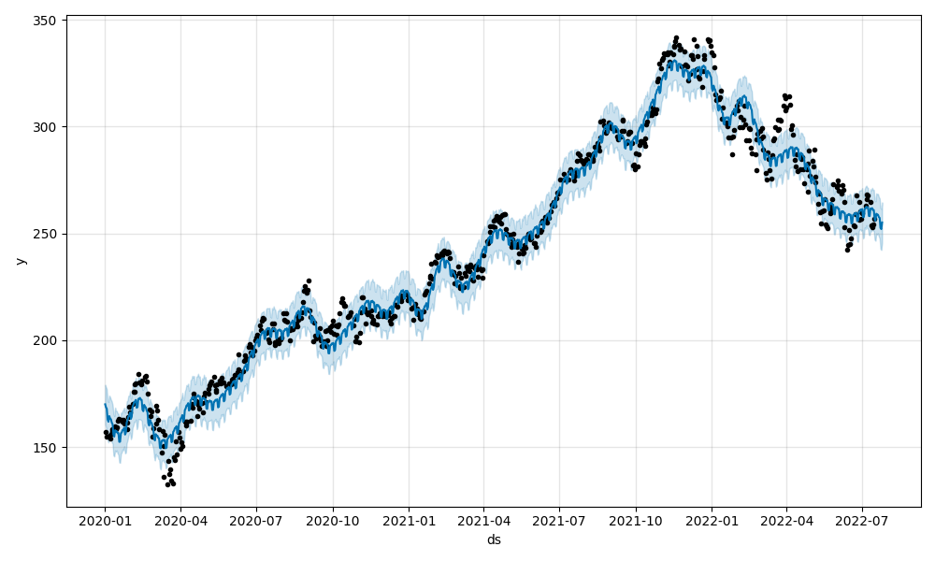](https://github.com/FourthBrain/MLE-11/blob/main/assignments/week-12-intro-mlops/img/MSFT_plot.png) [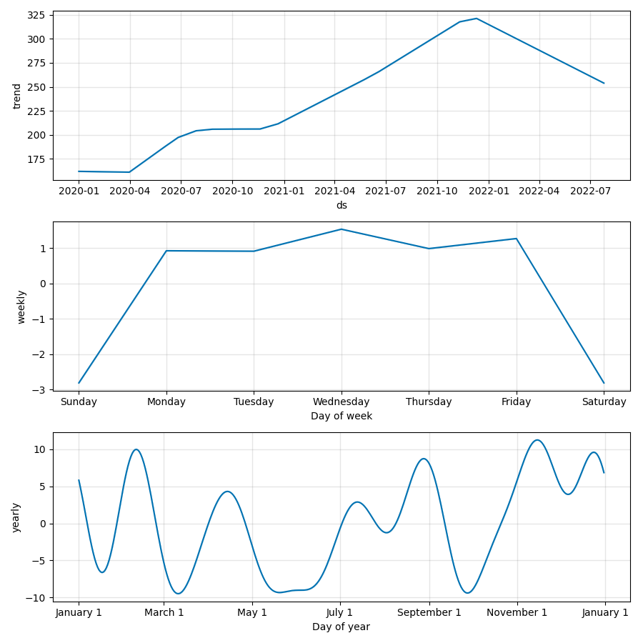](https://github.com/FourthBrain/MLE-11/blob/main/assignments/week-12-intro-mlops/img/MSFT_plot_components.png)

• Feel free to make more models, e.g.,

python model.py --ticker AAPL --days 7

python model.py --ticker GOOG --days 7

• Push your changes as you go, as long as there are no errors.

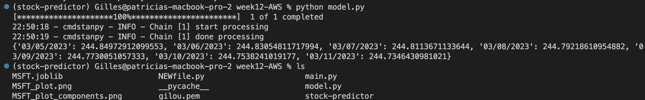

**Running Python main.py creates pictures of stock price and stock price variations. AJG_plot_components.png for AJ Gallagher.**

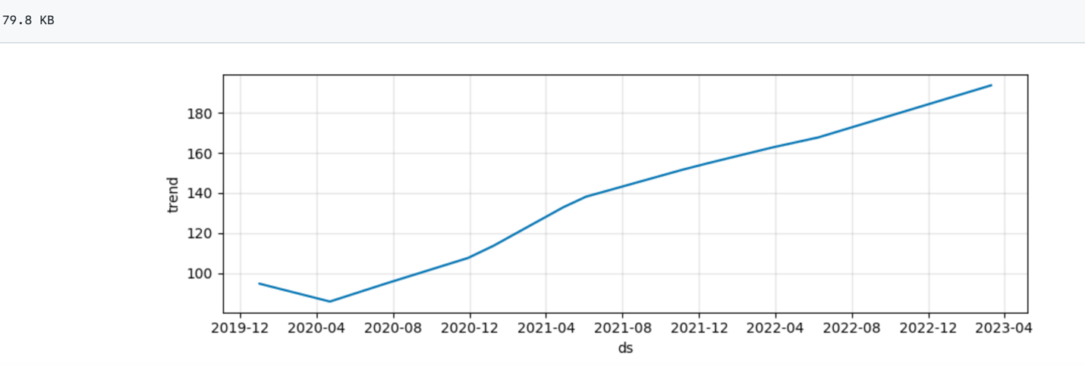

**Task 3. Routes**

In this task, we will wire up our API.

1. Add a /predict endpoint by updating main.py:
2. from fastapi import FastAPI, Query, HTTPException
3. from pydantic import BaseModel
4. from model import predict, convert
5. app = FastAPI()
6. # pydantic models
7. class StockIn(BaseModel):
8. ticker: str
9. days: int
10. class StockOut(StockIn):
11. forecast: dict
12. @app.post("/predict", response_model=StockOut, status_code=200)
13. def get_prediction(payload: StockIn):
14. ticker = payload.ticker
15. days = payload.days
16. prediction_list = predict(ticker, days)
17. if not prediction_list:
18. raise HTTPException(status_code=400, detail="Model not found.")
19. response_object = {
20. "ticker": ticker,
21. "days": days,
22. "forecast": convert(prediction_list)}

return response_object

So, in the new function get_prediction, we passed in a ticker to our model's predict and then used convert to create the output for the response object. We also took advantage of a pydantic [schema](https://pydantic-docs.helpmanual.io/usage/schema/) to covert the JSON payload to a StockIn object schema. This provides automatic type validation. The response object uses the StockOut schema object to convert the Python dict - {"ticker": ticker, "days": days, "forecast": convert(prediction_list)} - to JSON, which, again, is validated.

1. Disable plotting for the web app. Let's just output the forecast in JSON. Comment out the following lines in predict in model.py:
2. # model.plot(forecast).savefig(f"{ticker}_plot.png")

# model.plot_components(forecast).savefig(f"{ticker}_plot_components.png")

Optional: Comment out or remove the if name == __main__ block in model.py.

1. Run the app locally.

uvicorn main:app --reload --workers 1 --host 0.0.0.0 --port 8000

1. Test the endpoint. Open a new shell, use curl to test the endpoint:
2. curl \
3. --header "Content-Type: application/json" \
4. --request POST \
5. --data '{"ticker":"MSFT", "days":7}' \
6. http://0.0.0.0:8000/predict

You shall see something like:

{

"ticker":"MSFT",

"days":7,

"forecast":{

"07/20/2022":254.67755986604763,

"07/21/2022":254.3739109884936,

"07/22/2022":254.0702621109396,

"07/23/2022":253.7666132333857,

"07/24/2022":253.46296435583167,

"07/25/2022":253.15931547827768,

"07/26/2022":252.8556666007237

}

}

1. Try it with a different ticker. What happens if the input ticker doesn't have a trained model or the ticker is not valid?
2. Navigate to http://127.0.0.1:8000/docs (or http://localhost:8000/docs) and see the interactive API documentation (you can take a sneak peek [here](http://35.90.247.255:8000/docs)).

conda list | grep uvicorn

uvicorn 0.20.0 pypi_0 pypi

pip list --format=freeze > requirements.txt

**http://localhost:8001/ docs#/default/get_prediction_predict_post** 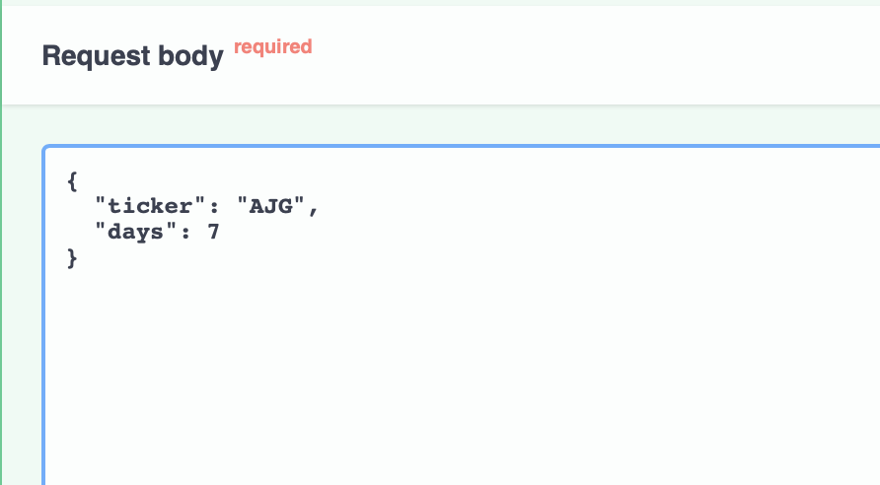

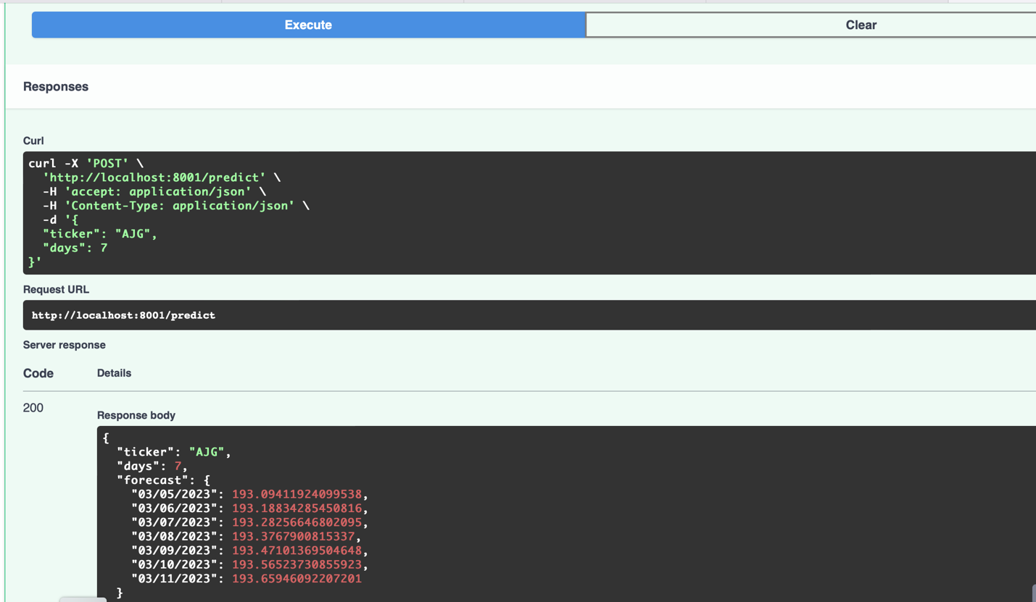

**python model.py --ticker AJG --days 7**

[*********************100%***********************] 1 of 1 completed

22:54:39 - cmdstanpy - INFO - Chain [1] start processing

22:54:39 - cmdstanpy - INFO - Chain [1] done processing

{'03/05/2023': 193.09411924099538, '03/06/2023': 193.18834285450816, '03/07/2023': 193.28256646802095, '03/08/2023': 193.3767900815337, '03/09/2023': 193.47101369504648, '03/10/2023': 193.56523730855923, '03/11/2023': 193.65946092207201}

**curl \**

**--header "Content-Type: application/json" \**

**--request POST \**

**--data '{"ticker":"MSFT", "days":7}' \**

[**http://0.0.0.0:8001/predict**](http://0.0.0.0:8001/predict)

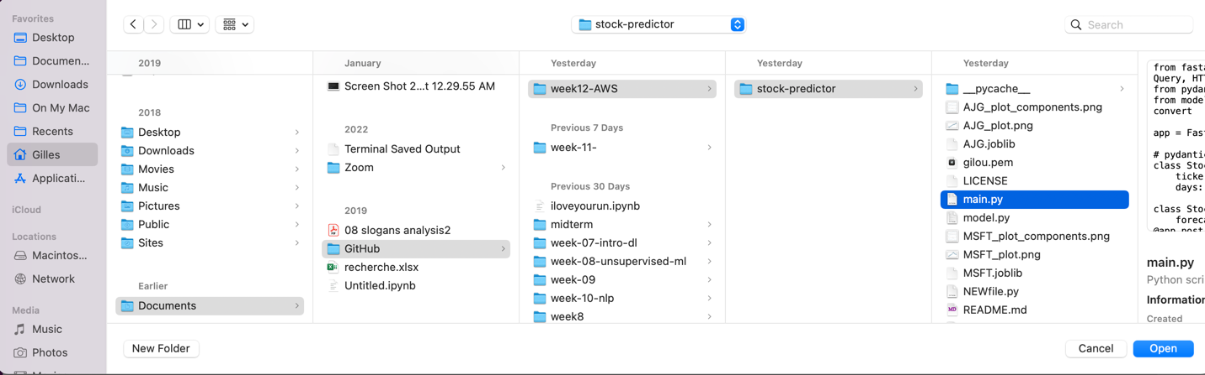**open file main.py in vscode / open model.py in vscode / open a terminal set on this spot and activate the stock-predictor environment.**

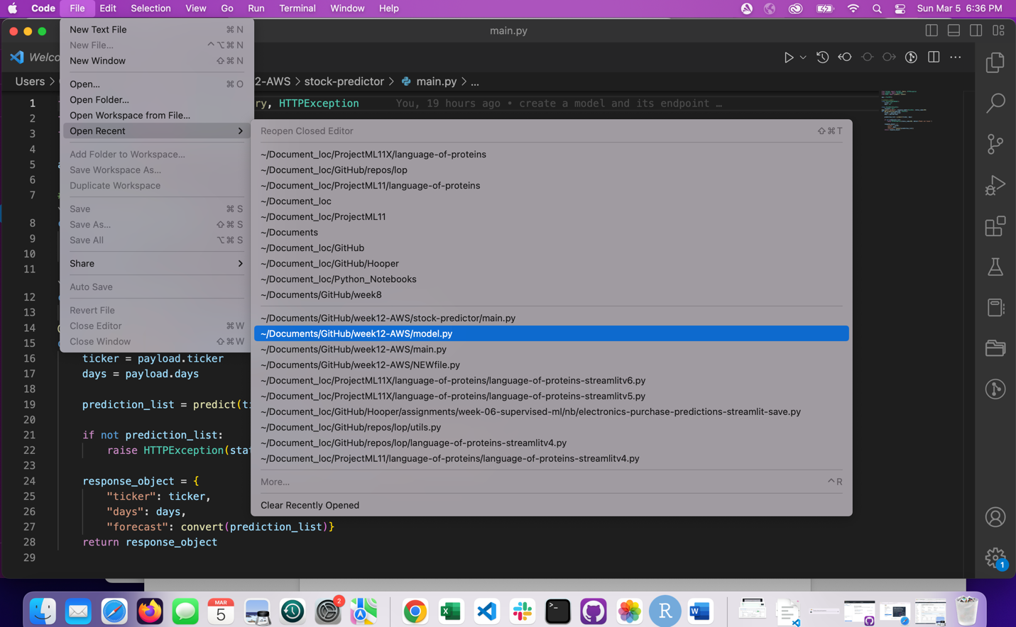

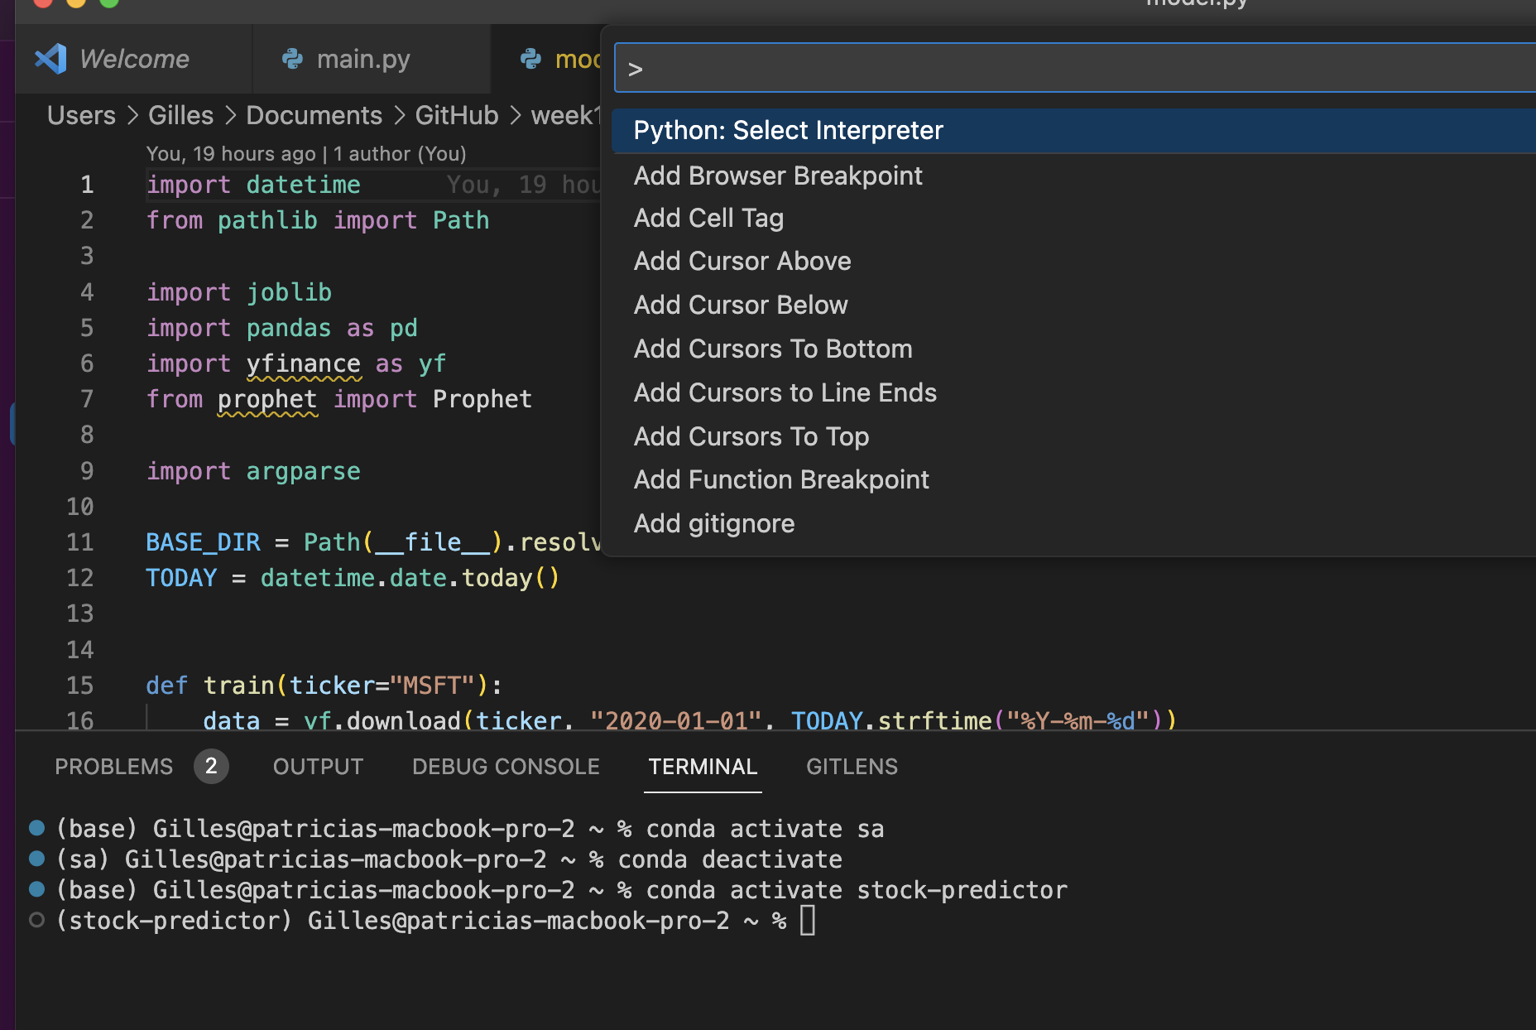

**Ctrl shift P**

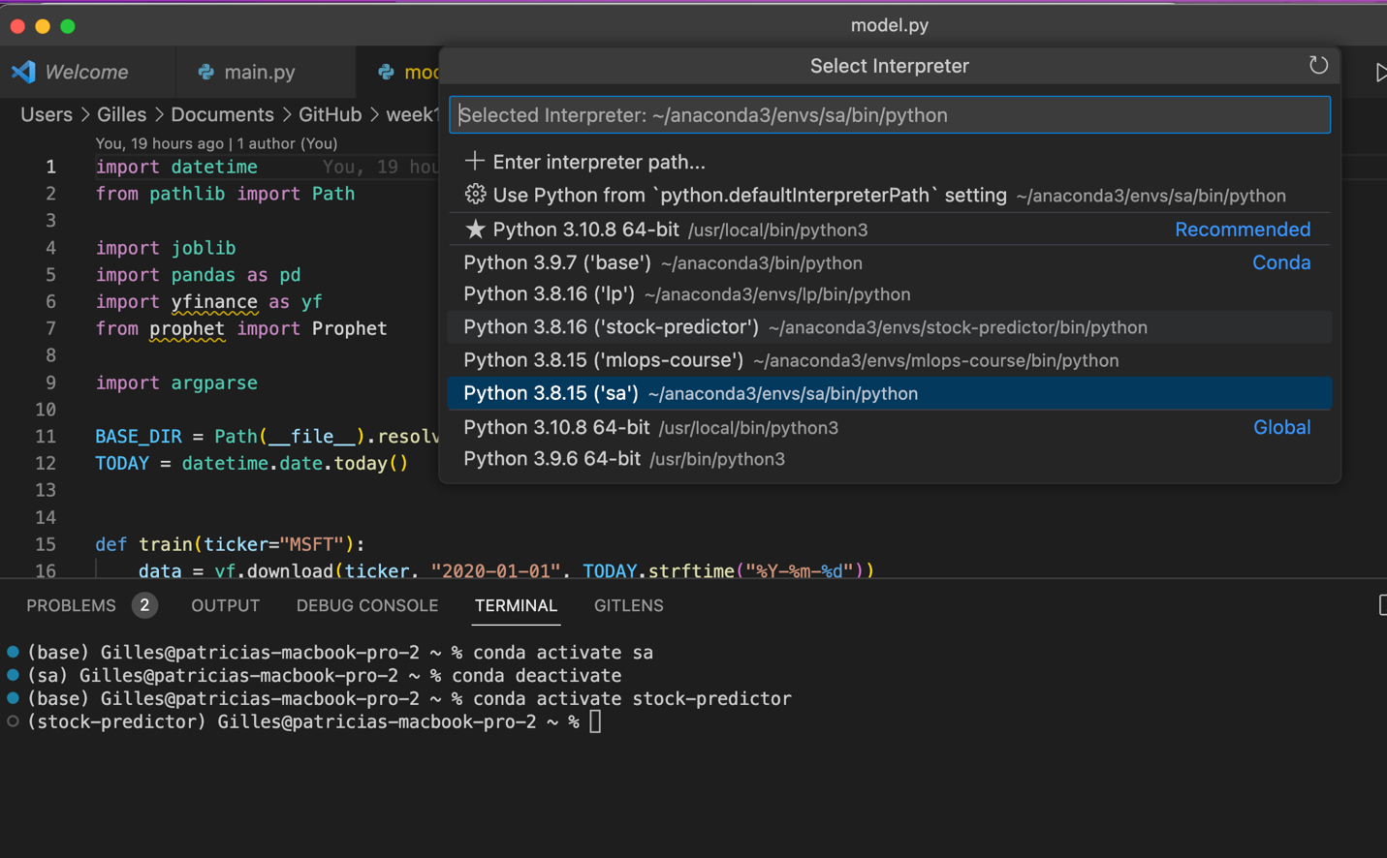

**Start the web site**

uvicorn main:app --reload --workers 1 --host 0.0.0.0 --port 8000

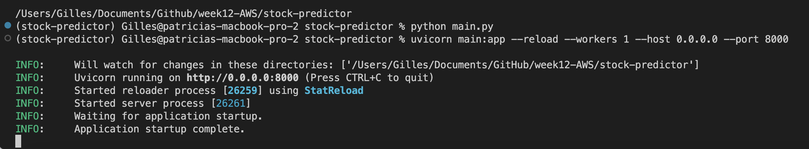

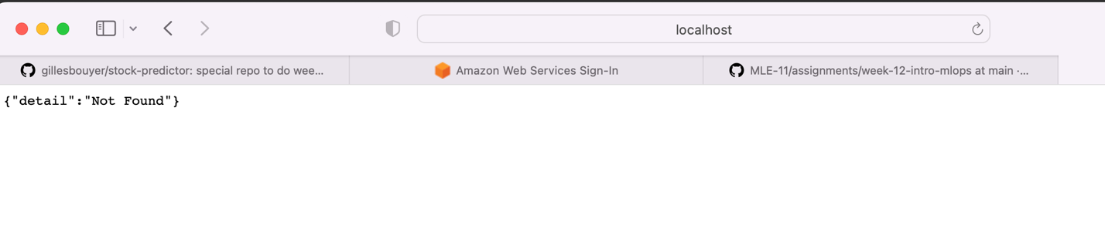

**Type in a new terminal**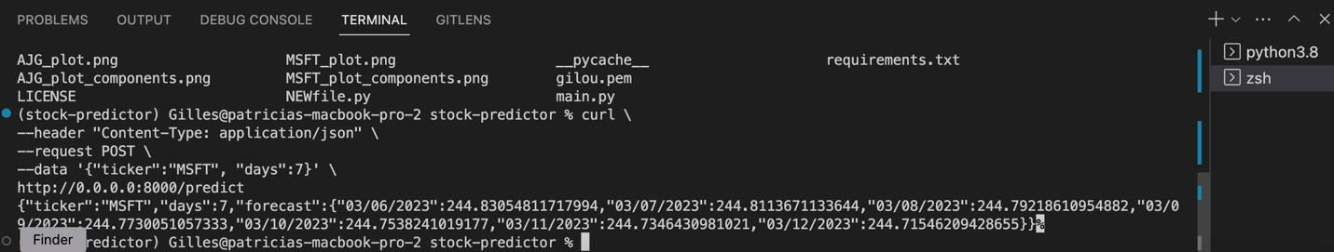

**curl \**

**--header "Content-Type: application/json" \**

**--request POST \**

**--data '{"ticker":"MSFT", "days":7}' \**

**http://0.0.0.0:8000/predict**

**{"ticker":"MSFT","days":7,"forecast":{"03/06/2023":244.83054811717994,"03/07/2023":244.8113671133644,"03/08/2023":244.79218610954882,"03/09/2023":244.7730051057333,"03/10/2023":244.7538241019177,"03/11/2023":244.7346430981021,"03/12/2023":244.71546209428655}}%**

**Go to the website**

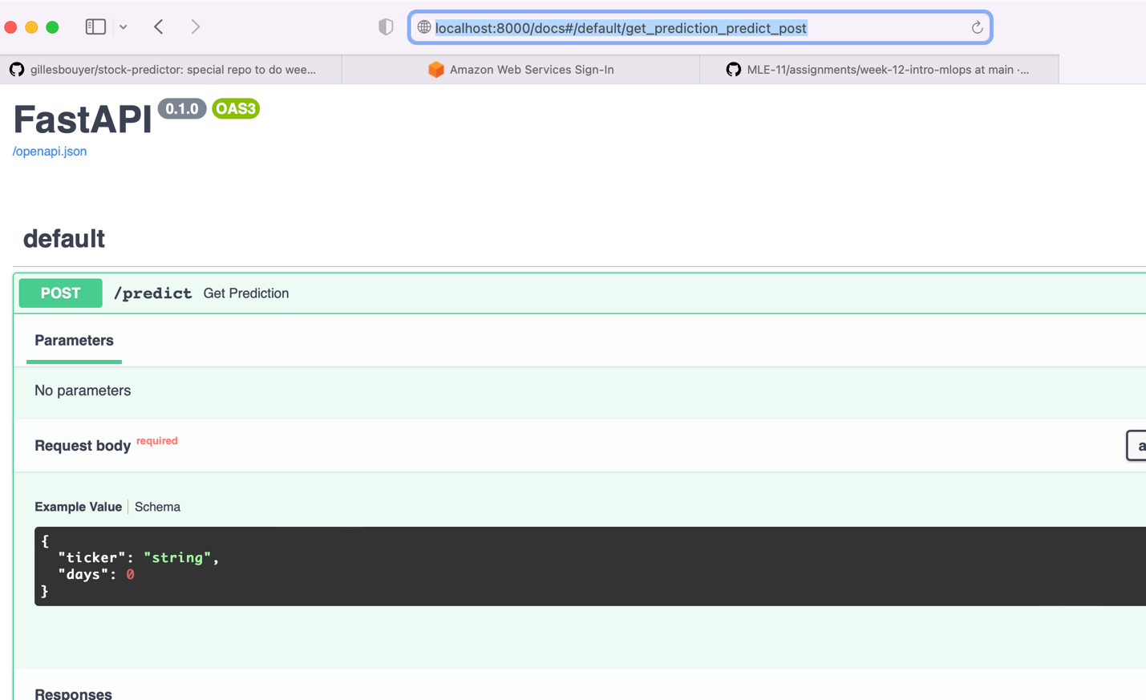**[http://localhost:8000/docs#/default/get_prediction_predict_post](http://localhost:8000/docs#/default)**

**[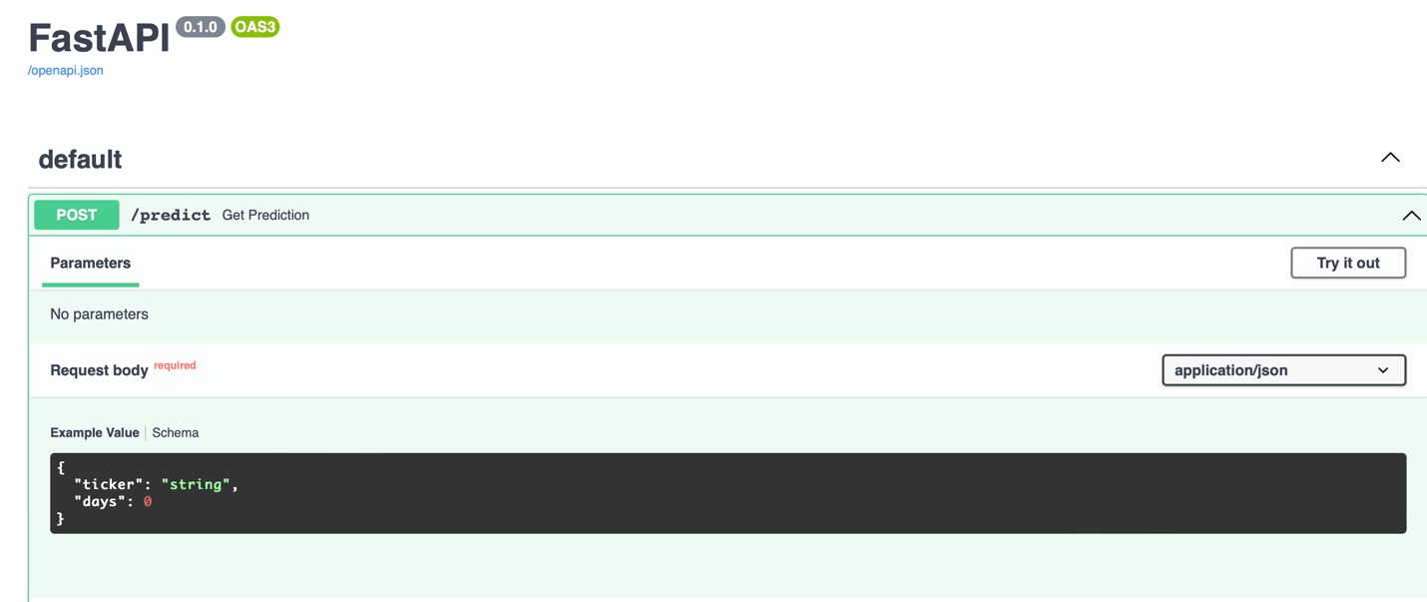](http://localhost:8000/docs#/default)**

**Replace string by AJG And 0 by 14 (CLICK ON TRY IT OUT)**

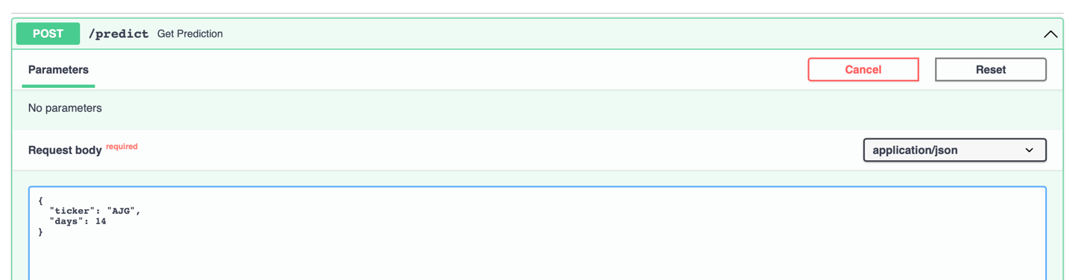



**Click on execute**

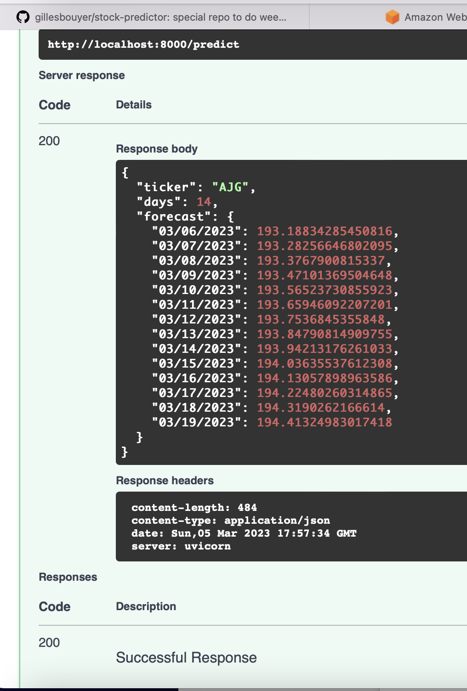

**Successful response**

**I save the repo**

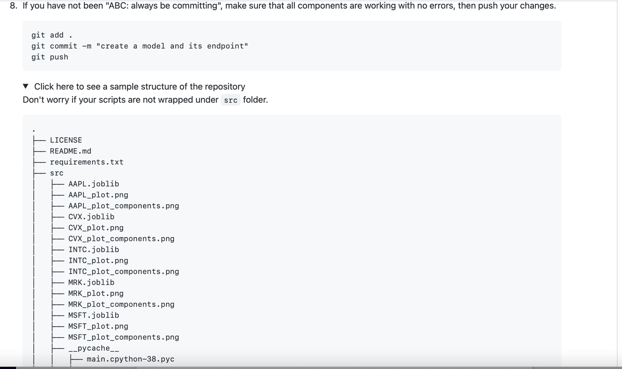

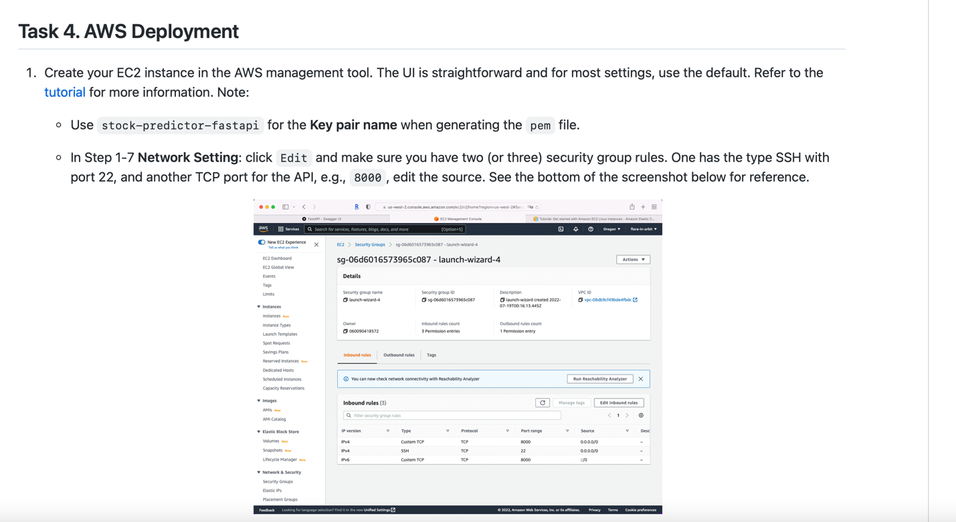

**Log in:** [**http://aws.amazon.com**](http://aws.amazon.com)

**681261969843**

[**Gilles.bouyer@gmail.com**](mailto:Gilles.bouyer@gmail.com)

**Gallagher5%**

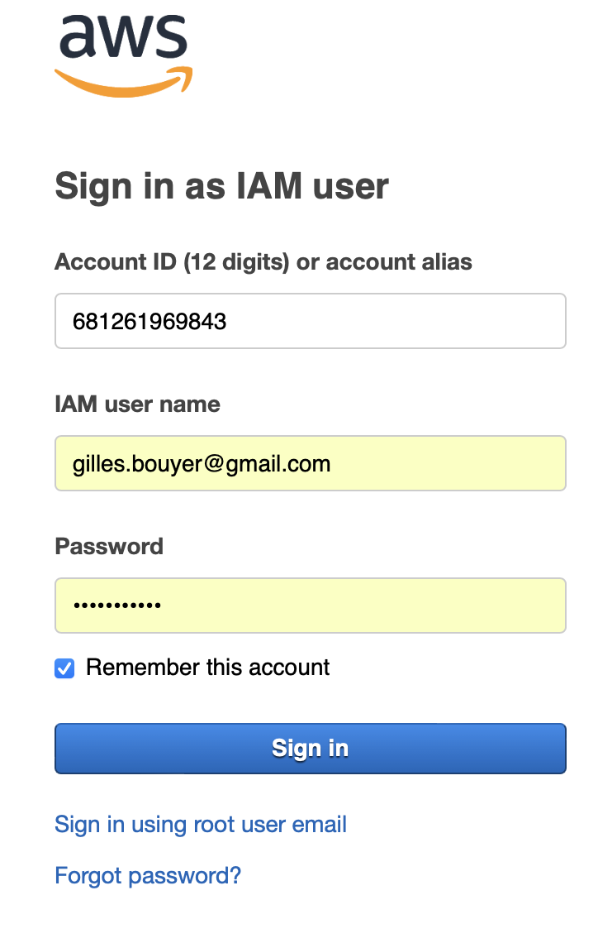

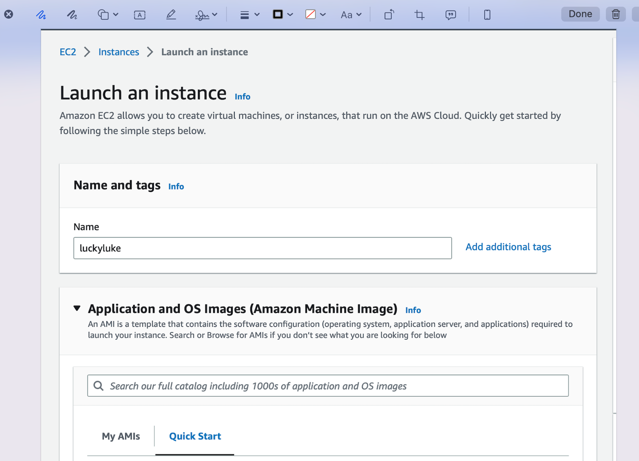

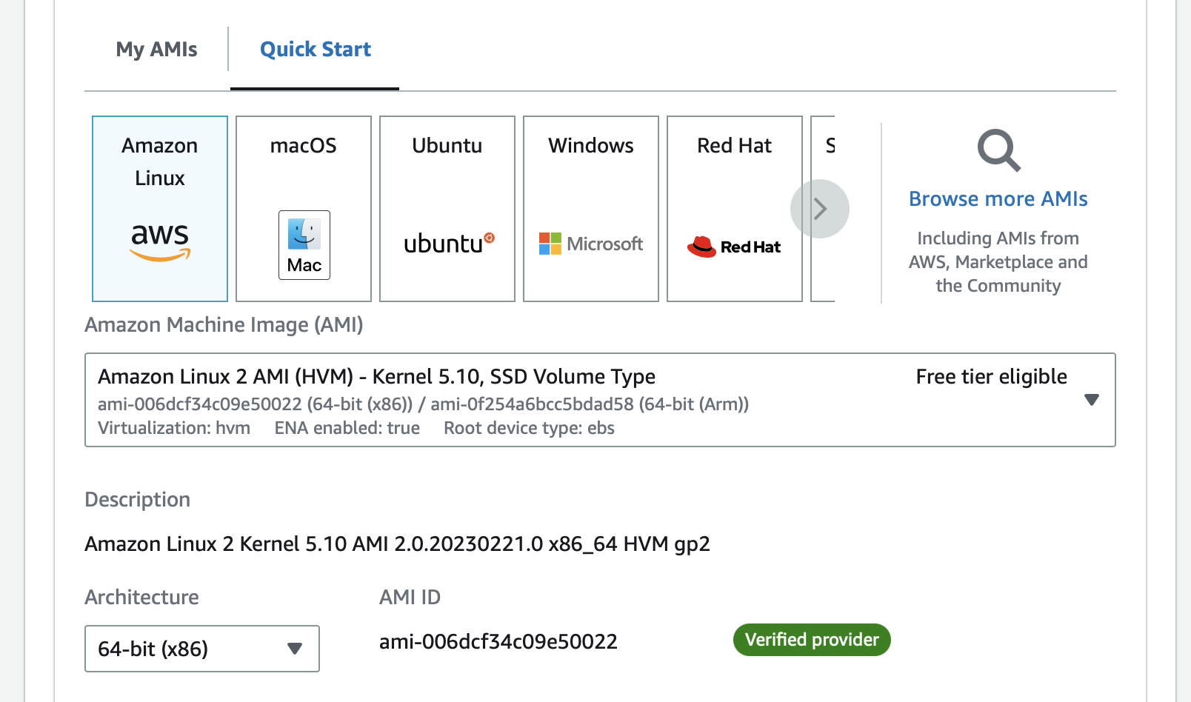

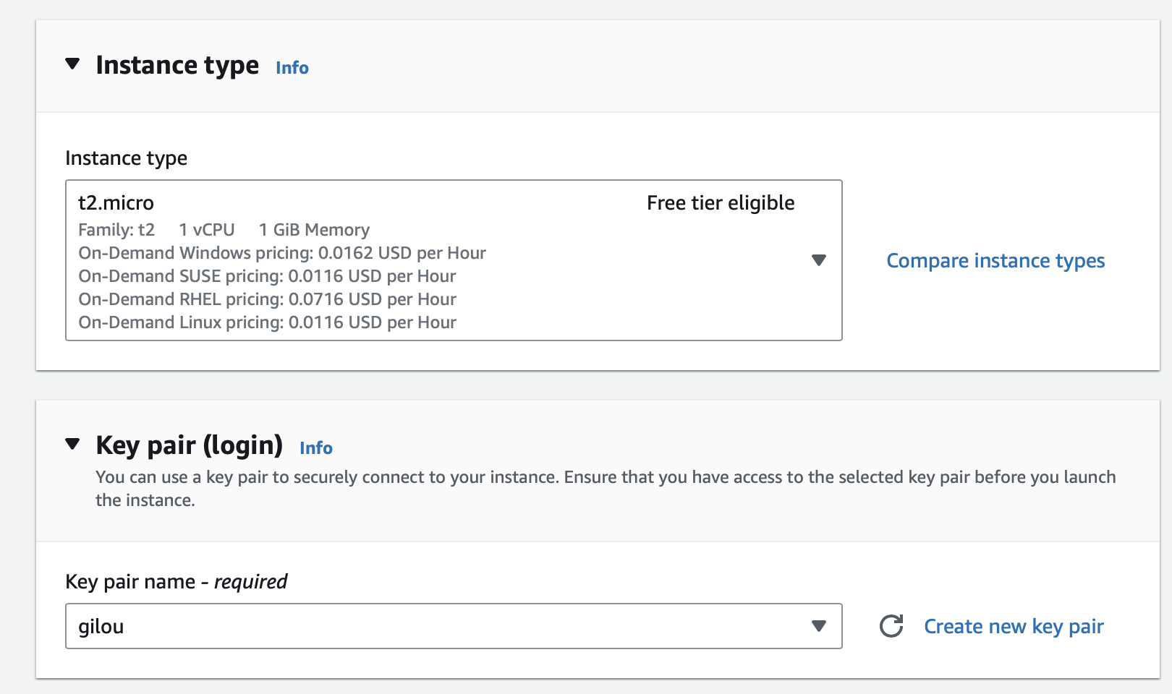

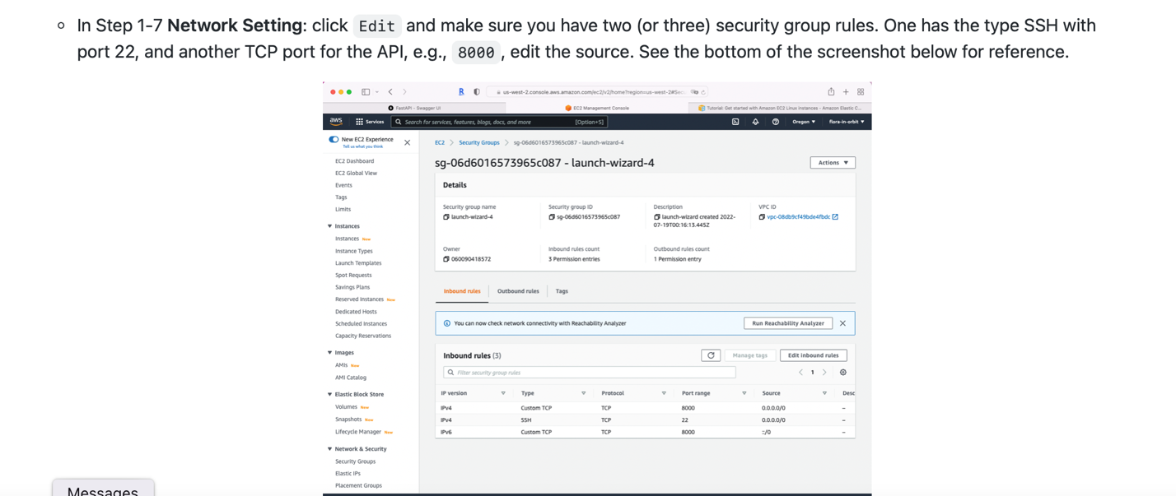

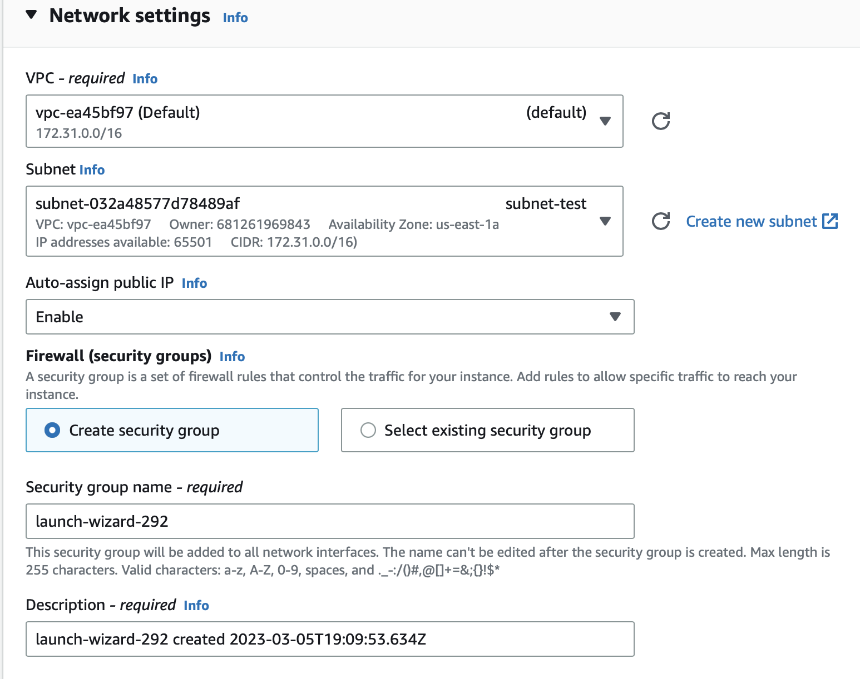

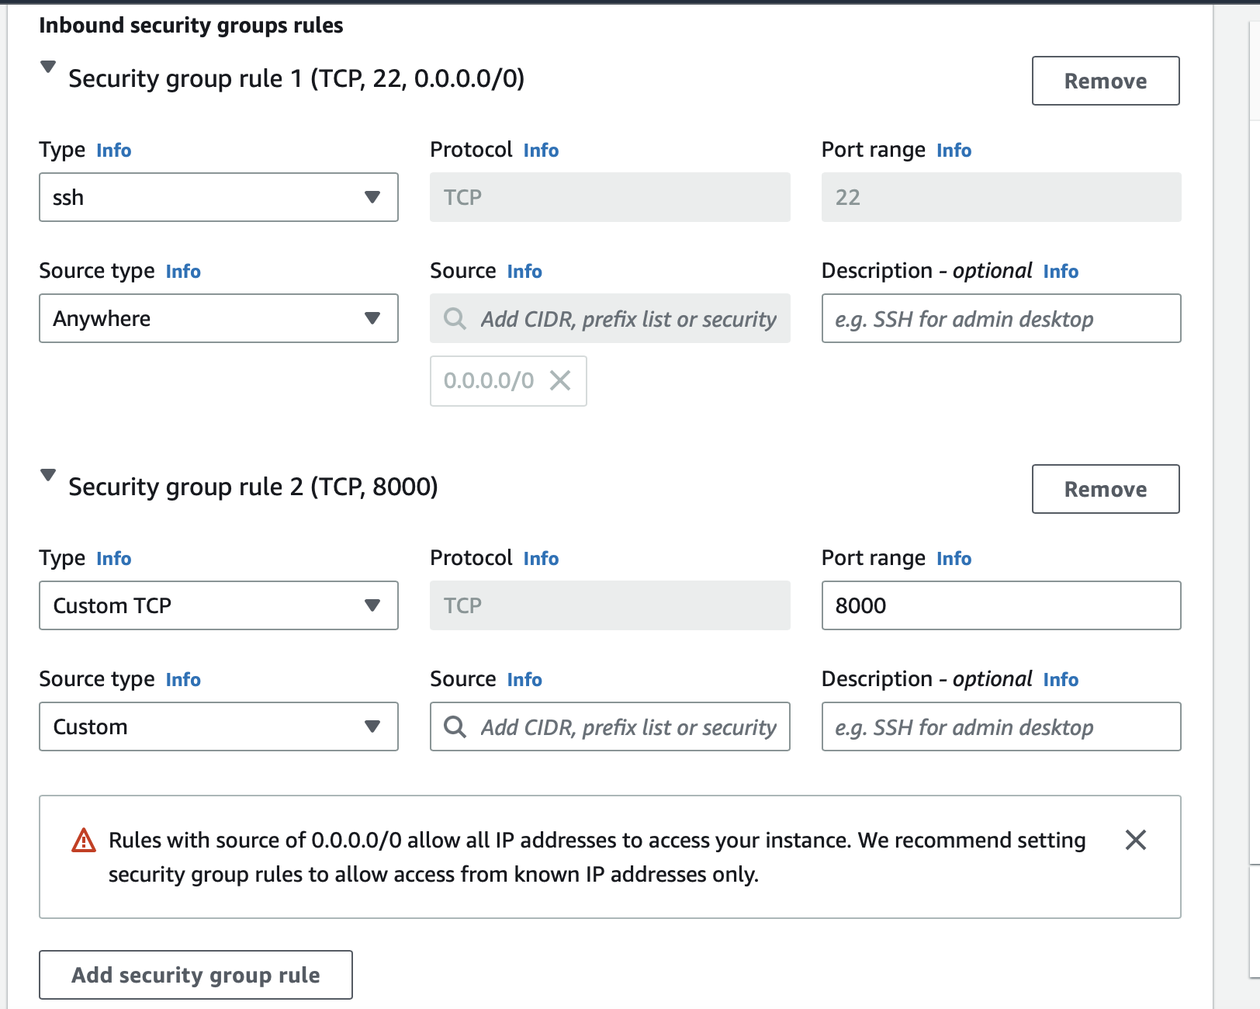

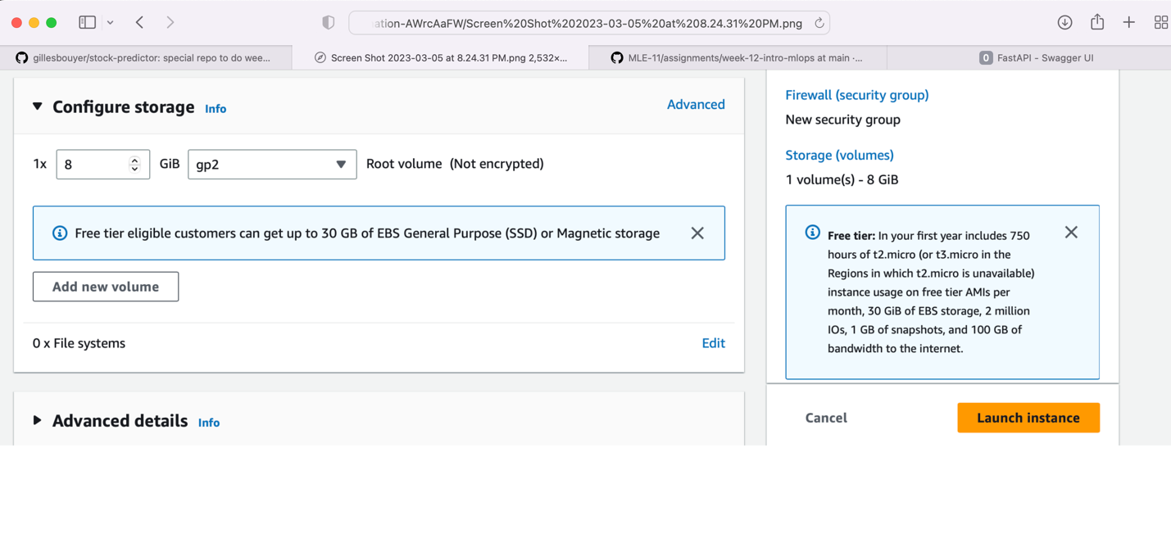



chmod 400 stock-predictor-fastapi.pem

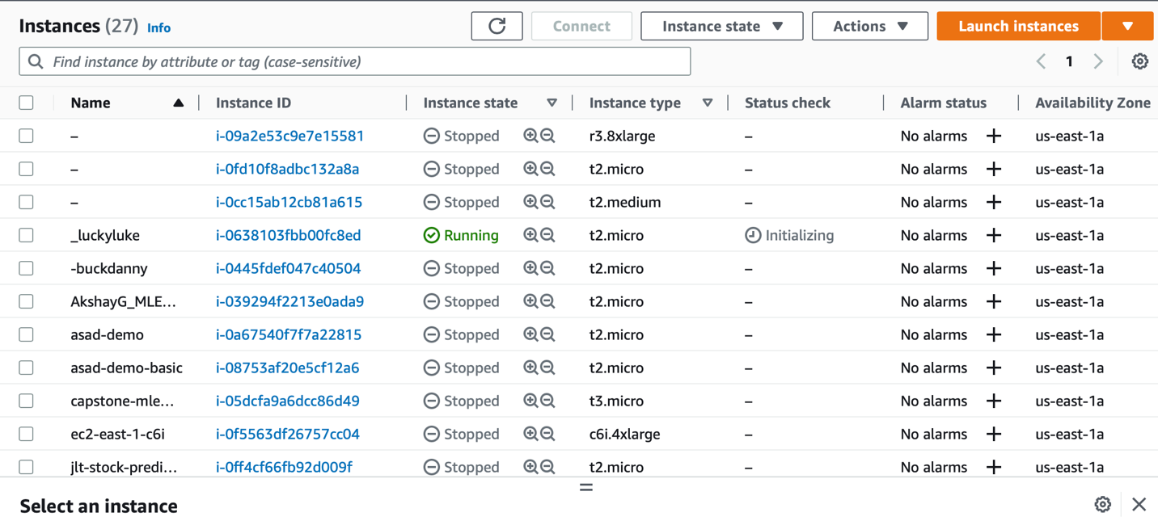

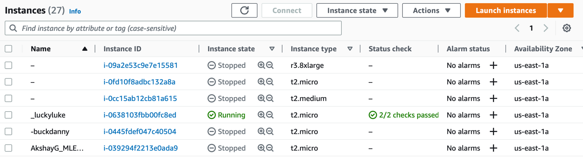

**ssh -i "gilou.pem"** [**ec2-user@ec2-3-94-125-15.compute-1.amazonaws.com**](mailto:ec2-user@ec2-3-94-125-15.compute-1.amazonaws.com)

**The authenticity of host 'ec2-3-94-125-15.compute-1.amazonaws.com (3.94.125.15)' can't be established.**

**ED25519 key fingerprint is SHA256:gYhEH0sHsnpbrcxnzYAqKZI7wlfIDzIuwIbOoKElfRw.**

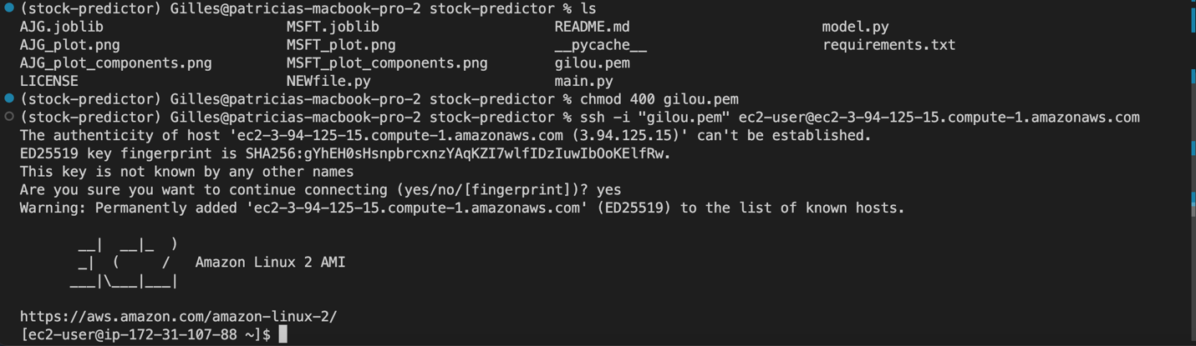

**ec2-user@ip-172-31-107-88 ~]$**

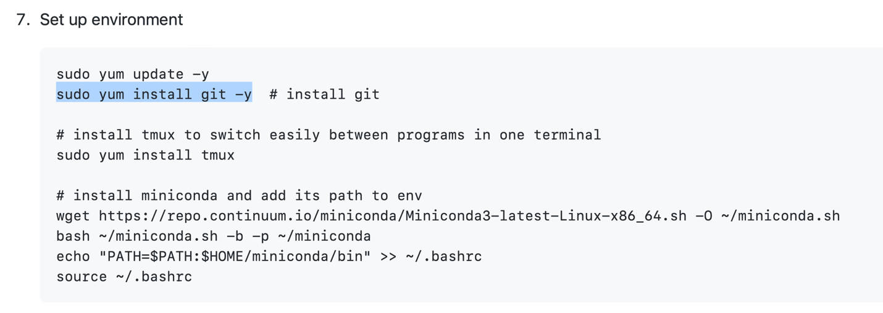

**[ec2-user@ip-172-31-107-88 ~]$ sudo yum update -y**

**Loaded plugins: extras_suggestions, langpacks, priorities, update-motd**

**amzn2-core | 3.7 kB 00:00:00**

**No packages marked for update**

**[ec2-user@ip-172-31-107-88 ~]$ sudo yum install git -y**

**Loaded plugins: extras_suggestions, langpacks, priorities, update-motd**

**Resolving Dependencies**

**--> Running transaction check**

**---> Package git.x86_64 0:2.39.1-1.amzn2.0.1 will be installed**

**--> Processing Dependency: perl-Git = 2.39.1-1.amzn2.0.1 for package: git-2.39.1-1.amzn2.0.1.x86_64**

**--> Processing Dependency: git-core-doc = 2.39.1-1.amzn2.0.1 for package: git-2.39.1-1.amzn2.0.1.x86_64**

**--> Processing Dependency: git-core = 2.39.1-1.amzn2.0.1 for package: git-2.39.1-1.amzn2.0.1.x86_64**

**--> Processing Dependency: perl(Term::ReadKey) for package: git-2.39.1-1.amzn2.0.1.x86_64**

**--> Processing Dependency: perl(Git::I18N) for package: git-2.39.1-1.amzn2.0.1.x86_64**

**--> Processing Dependency: perl(Git) for package: git-2.39.1-1.amzn2.0.1.x86_64**

**--> Running transaction check**

**---> Package git-core.x86_64 0:2.39.1-1.amzn2.0.1 will be installed**

**---> Package git-core-doc.noarch 0:2.39.1-1.amzn2.0.1 will be installed**

**---> Package perl-Git.noarch 0:2.39.1-1.amzn2.0.1 will be installed**

**--> Processing Dependency: perl(Error) for package: perl-Git-2.39.1-1.amzn2.0.1.noarch**

**---> Package perl-TermReadKey.x86_64 0:2.30-20.amzn2.0.2 will be installed**

**--> Running transaction check**

**---> Package perl-Error.noarch 1:0.17020-2.amzn2 will be installed**

**--> Finished Dependency Resolution**

**Dependencies Resolved**

**==========================================================================================================================================**

**Package Arch Version Repository Size**

**==========================================================================================================================================**

**Installing:**

**git x86_64 2.39.1-1.amzn2.0.1 amzn2-core 65 k**

**Installing for dependencies:**

**git-core x86_64 2.39.1-1.amzn2.0.1 amzn2-core 8.8 M**

**git-core-doc noarch 2.39.1-1.amzn2.0.1 amzn2-core 2.9 M**

**perl-Error noarch 1:0.17020-2.amzn2 amzn2-core 32 k**

**perl-Git noarch 2.39.1-1.amzn2.0.1 amzn2-core 41 k**

**perl-TermReadKey x86_64 2.30-20.amzn2.0.2 amzn2-core 31 k**

**Transaction Summary**

**==========================================================================================================================================**

**Install 1 Package (+5 Dependent packages)**

**Total download size: 12 M**

**Installed size: 43 M**

**Downloading packages:**

**(1/6): git-2.39.1-1.amzn2.0.1.x86_64.rpm | 65 kB 00:00:00**

**(2/6): git-core-doc-2.39.1-1.amzn2.0.1.noarch.rpm | 2.9 MB 00:00:00**

**(3/6): git-core-2.39.1-1.amzn2.0.1.x86_64.rpm | 8.8 MB 00:00:00**

**(4/6): perl-Error-0.17020-2.amzn2.noarch.rpm | 32 kB 00:00:00**

**(5/6): perl-Git-2.39.1-1.amzn2.0.1.noarch.rpm | 41 kB 00:00:00**

**(6/6): perl-TermReadKey-2.30-20.amzn2.0.2.x86_64.rpm | 31 kB 00:00:00**

**------------------------------------------------------------------------------------------------------------------------------------------**

**Total 24 MB/s | 12 MB 00:00:00**

**Running transaction check**

**Running transaction test**

**Transaction test succeeded**

**Running transaction**

**Installing : git-core-2.39.1-1.amzn2.0.1.x86_64 1/6**

**Installing : git-core-doc-2.39.1-1.amzn2.0.1.noarch 2/6**

**Installing : 1:perl-Error-0.17020-2.amzn2.noarch 3/6**

**Installing : perl-TermReadKey-2.30-20.amzn2.0.2.x86_64 4/6**

**Installing : perl-Git-2.39.1-1.amzn2.0.1.noarch 5/6**

**Installing : git-2.39.1-1.amzn2.0.1.x86_64 6/6**

**Verifying : perl-TermReadKey-2.30-20.amzn2.0.2.x86_64 1/6**

**Verifying : git-core-doc-2.39.1-1.amzn2.0.1.noarch 2/6**

**Verifying : git-2.39.1-1.amzn2.0.1.x86_64 3/6**

**Verifying : perl-Git-2.39.1-1.amzn2.0.1.noarch 4/6**

**Verifying : git-core-2.39.1-1.amzn2.0.1.x86_64 5/6**

**Verifying : 1:perl-Error-0.17020-2.amzn2.noarch 6/6**

**Installed:**

**git.x86_64 0:2.39.1-1.amzn2.0.1**

**Dependency Installed:**

**git-core.x86_64 0:2.39.1-1.amzn2.0.1 git-core-doc.noarch 0:2.39.1-1.amzn2.0.1 perl-Error.noarch 1:0.17020-2.amzn2**

**perl-Git.noarch 0:2.39.1-1.amzn2.0.1 perl-TermReadKey.x86_64 0:2.30-20.amzn2.0.2**

**Complete!**

**ec2-user@ip-172-31-107-88 ~]$ sudo yum install tmux**

**Loaded plugins: extras_suggestions, langpacks, priorities, update-motd**

**Resolving Dependencies**

**--> Running transaction check**

**---> Package tmux.x86_64 0:1.8-4.amzn2.0.1 will be installed**

**--> Finished Dependency Resolution**

**Dependencies Resolved**

**==========================================================================================================================================**

**Package Arch Version Repository Size**

**==========================================================================================================================================**

**Installing:**

**tmux x86_64 1.8-4.amzn2.0.1 amzn2-core 244 k**

**Transaction Summary**

**==========================================================================================================================================**

**Install 1 Package**

**Total download size: 244 k**

**Installed size: 559 k**

**Is this ok [y/d/N]: y**

**Downloading packages:**

**tmux-1.8-4.amzn2.0.1.x86_64.rpm | 244 kB 00:00:00**

**Running transaction check**

**Running transaction test**

**Transaction test succeeded**

**Running transaction**

**Installing : tmux-1.8-4.amzn2.0.1.x86_64 1/1**

**Verifying : tmux-1.8-4.amzn2.0.1.x86_64 1/1**

**Installed:**

**tmux.x86_64 0:1.8-4.amzn2.0.1**

**Complete!**

**[ec2-user@ip-172-31-107-88 ~]$ wget https://repo.continuum.io/miniconda/Miniconda3-latest-Linux-x86_64.sh -O ~/miniconda.sh**

**--2023-03-05 19:49:18-- https://repo.continuum.io/miniconda/Miniconda3-latest-Linux-x86_64.sh**

**Resolving repo.continuum.io (repo.continuum.io)... 104.18.201.79, 104.18.200.79, 2606:4700::6812:c84f, ...**

**Connecting to repo.continuum.io (repo.continuum.io)|104.18.201.79|:443... connected.**

**HTTP request sent, awaiting response... 301 Moved Permanently**

**Location: https://repo.anaconda.com/miniconda/Miniconda3-latest-Linux-x86_64.sh [following]**

**--2023-03-05 19:49:18-- https://repo.anaconda.com/miniconda/Miniconda3-latest-Linux-x86_64.sh**

**Resolving repo.anaconda.com (repo.anaconda.com)... 104.16.130.3, 104.16.131.3, 2606:4700::6810:8303, ...**

**Connecting to repo.anaconda.com (repo.anaconda.com)|104.16.130.3|:443... connected.**

**HTTP request sent, awaiting response... 200 OK**

**Length: 74403966 (71M) [application/x-sh]**

**Saving to: ‘/home/ec2-user/miniconda.sh’**

**100%[================================================================================================>] 74,403,966 102MB/s in 0.7s**

**2023-03-05 19:49:19 (102 MB/s) - ‘/home/ec2-user/miniconda.sh’ saved [74403966/74403966]**

**[ec2-user@ip-172-31-107-88 ~]$ bash ~/miniconda.sh -b -p ~/miniconda**

**PREFIX=/home/ec2-user/miniconda**

**Unpacking payload ...**

**Installing base environment...**

**Downloading and Extracting Packages**

**Downloading and Extracting Packages**

**Preparing transaction: done**

**Executing transaction: done**

**installation finished.**

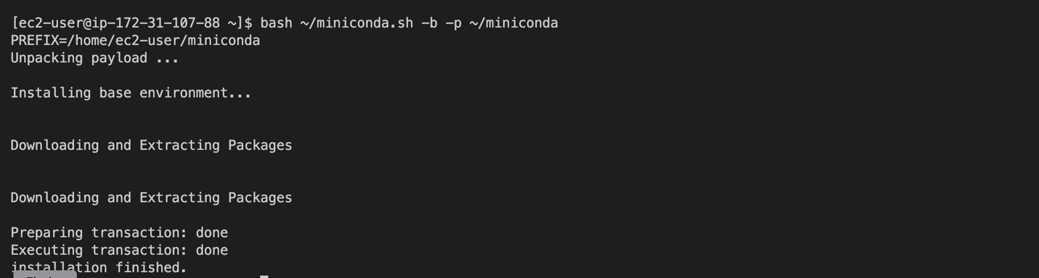

**[ec2-user@ip-172-31-107-88 ~]$ echo "PATH=$PATH:$HOME/miniconda/bin" >> ~/.bashrc**

**[ec2-user@ip-172-31-107-88 ~]$ source ~/.bashrc**

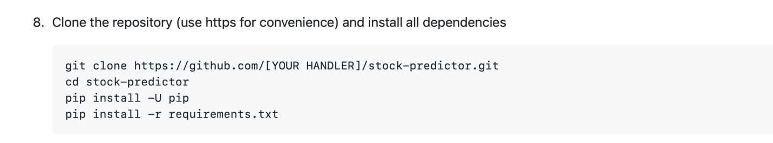

**git clone https://github.com/gillesbouyer/stock-predictor. git** 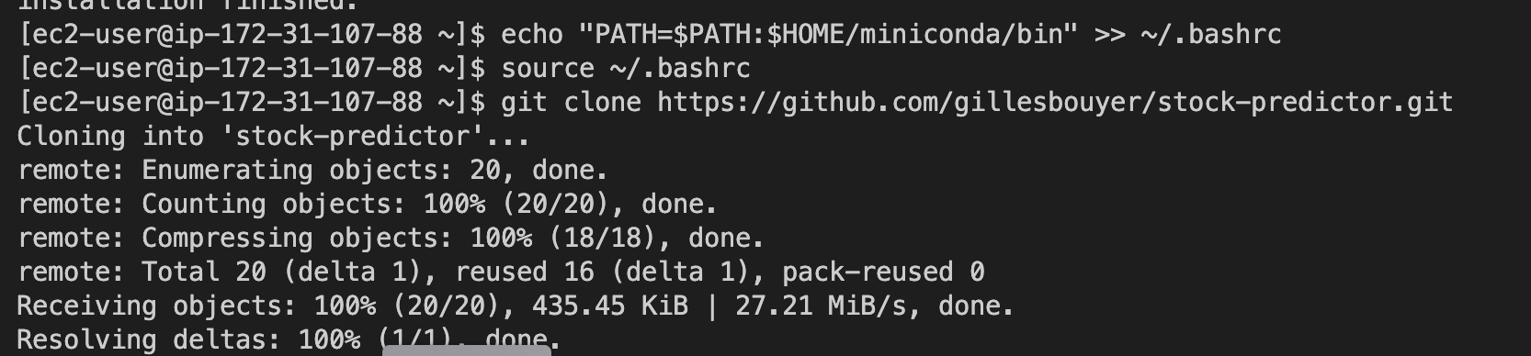

**[ec2-user@ip-172-31-107-88 ~]$ ls**

**miniconda miniconda.sh stock-predictor**

**[ec2-user@ip-172-31-107-88 ~]$ cd stock-predictor**

**[ec2-user@ip-172-31-107-88 stock-predictor]$ pip install -U pip**

**Requirement already satisfied: pip in /home/ec2-user/miniconda/lib/python3.10/site-packages (22.3.1)**

**Collecting pip**

**Downloading pip-23.0.1-py3-none-any.whl (2.1 MB)**

**━━━━━━━━━━━━━━━━━━━━━━━━━━━━━━━━━━━━━━━━ 2.1/2.1 MB 48.8 MB/s eta 0:00:00**

**Installing collected packages: pip**

**Attempting uninstall: pip**

**Found existing installation: pip 22.3.1**

**Uninstalling pip-22.3.1:**

**Successfully uninstalled pip-22.3.1**

**Successfully installed pip-23.0.1**

**[ec2-user@ip-172-31-107-88 stock-predictor]$ pip install -r requirements.txt**

[ec2-user@ip-172-31-107-88 stock-predictor]$ pip install -r requirements.txt

Collecting anyio==3.6.2

Downloading anyio-3.6.2-py3-none-any.whl (80 kB)

━━━━━━━━━━━━━━━━━━━━━━━━━━━━━━━━━━━━━━━━ 80.6/80.6 kB 15.9 MB/s eta 0:00:00

Collecting appdirs==1.4.4

Downloading appdirs-1.4.4-py2.py3-none-any.whl (9.6 kB)

Collecting beautifulsoup4==4.11.2

Downloading beautifulsoup4-4.11.2-py3-none-any.whl (129 kB)

━━━━━━━━━━━━━━━━━━━━━━━━━━━━━━━━━━━━━━━━ 129.4/129.4 kB 20.0 MB/s eta 0:00:00

Requirement already satisfied: certifi==2022.12.7 in /home/ec2-user/miniconda/lib/python3.10/site-packages (from -r requirements.txt (line 4)) (2022.12.7)

Requirement already satisfied: cffi==1.15.1 in /home/ec2-user/miniconda/lib/python3.10/site-packages (from -r requirements.txt (line 5)) (1.15.1)

Collecting charset-normalizer==3.0.1

Downloading charset_normalizer-3.0.1-cp310-cp310-manylinux_2_17_x86_64.manylinux2014_x86_64.whl (198 kB)

━━━━━━━━━━━━━━━━━━━━━━━━━━━━━━━━━━━━━━━━ 198.8/198.8 kB 37.5 MB/s eta 0:00:00

Collecting click==8.1.3

Downloading click-8.1.3-py3-none-any.whl (96 kB)

━━━━━━━━━━━━━━━━━━━━━━━━━━━━━━━━━━━━━━━━ 96.6/96.6 kB 22.3 MB/s eta 0:00:00

Collecting cmdstanpy==1.1.0

Downloading cmdstanpy-1.1.0-py3-none-any.whl (83 kB)

━━━━━━━━━━━━━━━━━━━━━━━━━━━━━━━━━━━━━━━━ 83.2/83.2 kB 22.0 MB/s eta 0:00:00

Collecting contourpy==1.0.7

Downloading contourpy-1.0.7-cp310-cp310-manylinux_2_17_x86_64.manylinux2014_x86_64.whl (300 kB)

━━━━━━━━━━━━━━━━━━━━━━━━━━━━━━━━━━━━━━━━ 300.3/300.3 kB 40.6 MB/s eta 0:00:00

Collecting convertdate==2.4.0

Downloading convertdate-2.4.0-py3-none-any.whl (47 kB)

━━━━━━━━━━━━━━━━━━━━━━━━━━━━━━━━━━━━━━━━ 47.9/47.9 kB 13.3 MB/s eta 0:00:00

Collecting cryptography==39.0.2

Downloading cryptography-39.0.2-cp36-abi3-manylinux_2_24_x86_64.whl (4.1 MB)

━━━━━━━━━━━━━━━━━━━━━━━━━━━━━━━━━━━━━━━━ 4.1/4.1 MB 71.8 MB/s eta 0:00:00

Collecting cycler==0.11.0

Downloading cycler-0.11.0-py3-none-any.whl (6.4 kB)

Collecting ephem==4.1.4

Downloading ephem-4.1.4-cp310-cp310-manylinux_2_17_x86_64.manylinux2014_x86_64.whl (1.8 MB)

━━━━━━━━━━━━━━━━━━━━━━━━━━━━━━━━━━━━━━━━ 1.8/1.8 MB 58.7 MB/s eta 0:00:00

Collecting fastapi==0.92.0

Downloading fastapi-0.92.0-py3-none-any.whl (56 kB)

━━━━━━━━━━━━━━━━━━━━━━━━━━━━━━━━━━━━━━━━ 56.2/56.2 kB 14.1 MB/s eta 0:00:00

Collecting fonttools==4.38.0

Downloading fonttools-4.38.0-py3-none-any.whl (965 kB)

━━━━━━━━━━━━━━━━━━━━━━━━━━━━━━━━━━━━━━━━ 965.4/965.4 kB 67.3 MB/s eta 0:00:00

Collecting frozendict==2.3.5

Downloading frozendict-2.3.5-cp310-cp310-manylinux_2_17_x86_64.manylinux2014_x86_64.whl (113 kB)

━━━━━━━━━━━━━━━━━━━━━━━━━━━━━━━━━━━━━━━━ 113.4/113.4 kB 25.5 MB/s eta 0:00:00

Collecting h11==0.14.0

Downloading h11-0.14.0-py3-none-any.whl (58 kB)

━━━━━━━━━━━━━━━━━━━━━━━━━━━━━━━━━━━━━━━━ 58.3/58.3 kB 15.6 MB/s eta 0:00:00

Collecting hijri-converter==2.2.4

Downloading hijri_converter-2.2.4-py3-none-any.whl (14 kB)

Collecting holidays==0.20

Downloading holidays-0.20-py3-none-any.whl (226 kB)

━━━━━━━━━━━━━━━━━━━━━━━━━━━━━━━━━━━━━━━━ 226.5/226.5 kB 43.6 MB/s eta 0:00:00

Collecting html5lib==1.1

Downloading html5lib-1.1-py2.py3-none-any.whl (112 kB)

━━━━━━━━━━━━━━━━━━━━━━━━━━━━━━━━━━━━━━━━ 112.2/112.2 kB 23.3 MB/s eta 0:00:00

Requirement already satisfied: idna==3.4 in /home/ec2-user/miniconda/lib/python3.10/site-packages (from -r requirements.txt (line 21)) (3.4)

Collecting importlib-resources==5.12.0

Downloading importlib_resources-5.12.0-py3-none-any.whl (36 kB)

Collecting joblib==1.2.0

Downloading joblib-1.2.0-py3-none-any.whl (297 kB)

━━━━━━━━━━━━━━━━━━━━━━━━━━━━━━━━━━━━━━━━ 298.0/298.0 kB 50.6 MB/s eta 0:00:00

Collecting kiwisolver==1.4.4

Downloading kiwisolver-1.4.4-cp310-cp310-manylinux_2_12_x86_64.manylinux2010_x86_64.whl (1.6 MB)

━━━━━━━━━━━━━━━━━━━━━━━━━━━━━━━━━━━━━━━━ 1.6/1.6 MB 70.4 MB/s eta 0:00:00

Collecting korean-lunar-calendar==0.3.1

Downloading korean_lunar_calendar-0.3.1-py3-none-any.whl (9.0 kB)

Collecting LunarCalendar==0.0.9

Downloading LunarCalendar-0.0.9-py2.py3-none-any.whl (18 kB)

Collecting lxml==4.9.2

Downloading lxml-4.9.2-cp310-cp310-manylinux_2_17_x86_64.manylinux2014_x86_64.manylinux_2_24_x86_64.whl (7.1 MB)

━━━━━━━━━━━━━━━━━━━━━━━━━━━━━━━━━━━━━━━━ 7.1/7.1 MB 70.8 MB/s eta 0:00:00

Collecting matplotlib==3.7.1

Downloading matplotlib-3.7.1-cp310-cp310-manylinux_2_17_x86_64.manylinux2014_x86_64.whl (11.6 MB)

━━━━━━━━━━━━━━━━━━━━━━━━━━━━━━━━━━━━━━━━ 11.6/11.6 MB 65.3 MB/s eta 0:00:00

Collecting multitasking==0.0.11

Downloading multitasking-0.0.11-py3-none-any.whl (8.5 kB)

Collecting numpy==1.24.2

Downloading numpy-1.24.2-cp310-cp310-manylinux_2_17_x86_64.manylinux2014_x86_64.whl (17.3 MB)

━━━━━━━━━━━━━━━━━━━━━━━━━━━━━━━━━━━━━━━━ 17.3/17.3 MB 36.7 MB/s eta 0:00:00

Collecting packaging==23.0

Downloading packaging-23.0-py3-none-any.whl (42 kB)

━━━━━━━━━━━━━━━━━━━━━━━━━━━━━━━━━━━━━━━━ 42.7/42.7 kB 10.4 MB/s eta 0:00:00

Collecting pandas==1.5.3

Downloading pandas-1.5.3-cp310-cp310-manylinux_2_17_x86_64.manylinux2014_x86_64.whl (12.1 MB)

━━━━━━━━━━━━━━━━━━━━━━━━━━━━━━━━━━━━━━━━ 12.1/12.1 MB 50.9 MB/s eta 0:00:00

Collecting Pillow==9.4.0

Downloading Pillow-9.4.0-cp310-cp310-manylinux_2_17_x86_64.manylinux2014_x86_64.whl (3.3 MB)

━━━━━━━━━━━━━━━━━━━━━━━━━━━━━━━━━━━━━━━━ 3.3/3.3 MB 67.9 MB/s eta 0:00:00

Collecting pip==22.3.1

Downloading pip-22.3.1-py3-none-any.whl (2.1 MB)

━━━━━━━━━━━━━━━━━━━━━━━━━━━━━━━━━━━━━━━━ 2.1/2.1 MB 69.5 MB/s eta 0:00:00

Collecting plotly==5.13.1

Downloading plotly-5.13.1-py2.py3-none-any.whl (15.2 MB)

━━━━━━━━━━━━━━━━━━━━━━━━━━━━━━━━━━━━━━━━ 15.2/15.2 MB 38.5 MB/s eta 0:00:00

Collecting prophet==1.1.2

Downloading prophet-1.1.2-py3-none-manylinux_2_17_x86_64.manylinux2014_x86_64.whl (8.9 MB)

━━━━━━━━━━━━━━━━━━━━━━━━━━━━━━━━━━━━━━━━ 8.9/8.9 MB 64.2 MB/s eta 0:00:00

Requirement already satisfied: pycparser==2.21 in /home/ec2-user/miniconda/lib/python3.10/site-packages (from -r requirements.txt (line 37)) (2.21)

Collecting pydantic==1.10.5

Downloading pydantic-1.10.5-cp310-cp310-manylinux_2_17_x86_64.manylinux2014_x86_64.whl (3.1 MB)

━━━━━━━━━━━━━━━━━━━━━━━━━━━━━━━━━━━━━━━━ 3.1/3.1 MB 69.8 MB/s eta 0:00:00

Collecting PyMeeus==0.5.12

Downloading PyMeeus-0.5.12.tar.gz (5.8 MB)

━━━━━━━━━━━━━━━━━━━━━━━━━━━━━━━━━━━━━━━━ 5.8/5.8 MB 64.2 MB/s eta 0:00:00

Preparing metadata (setup.py) ... done

Collecting pyparsing==3.0.9

Downloading pyparsing-3.0.9-py3-none-any.whl (98 kB)

━━━━━━━━━━━━━━━━━━━━━━━━━━━━━━━━━━━━━━━━ 98.3/98.3 kB 19.7 MB/s eta 0:00:00

Collecting python-dateutil==2.8.2

Downloading python_dateutil-2.8.2-py2.py3-none-any.whl (247 kB)

━━━━━━━━━━━━━━━━━━━━━━━━━━━━━━━━━━━━━━━━ 247.7/247.7 kB 45.9 MB/s eta 0:00:00

Collecting pytz==2022.7.1

Downloading pytz-2022.7.1-py2.py3-none-any.whl (499 kB)

━━━━━━━━━━━━━━━━━━━━━━━━━━━━━━━━━━━━━━━━ 499.4/499.4 kB 61.9 MB/s eta 0:00:00

Collecting requests==2.28.2

Downloading requests-2.28.2-py3-none-any.whl (62 kB)

━━━━━━━━━━━━━━━━━━━━━━━━━━━━━━━━━━━━━━━━ 62.8/62.8 kB 13.9 MB/s eta 0:00:00

Requirement already satisfied: setuptools==65.6.3 in /home/ec2-user/miniconda/lib/python3.10/site-packages (from -r requirements.txt (line 44)) (65.6.3)

Requirement already satisfied: six==1.16.0 in /home/ec2-user/miniconda/lib/python3.10/site-packages (from -r requirements.txt (line 45)) (1.16.0)

Collecting sniffio==1.3.0

Downloading sniffio-1.3.0-py3-none-any.whl (10 kB)

Collecting soupsieve==2.4

Downloading soupsieve-2.4-py3-none-any.whl (37 kB)

Collecting starlette==0.25.0

Downloading starlette-0.25.0-py3-none-any.whl (66 kB)

━━━━━━━━━━━━━━━━━━━━━━━━━━━━━━━━━━━━━━━━ 66.4/66.4 kB 16.8 MB/s eta 0:00:00

Collecting tenacity==8.2.2

Downloading tenacity-8.2.2-py3-none-any.whl (24 kB)

Collecting tqdm==4.65.0

Downloading tqdm-4.65.0-py3-none-any.whl (77 kB)

━━━━━━━━━━━━━━━━━━━━━━━━━━━━━━━━━━━━━━━━ 77.1/77.1 kB 18.3 MB/s eta 0:00:00

Collecting typing_extensions==4.5.0

Downloading typing_extensions-4.5.0-py3-none-any.whl (27 kB)

Requirement already satisfied: urllib3==1.26.14 in /home/ec2-user/miniconda/lib/python3.10/site-packages (from -r requirements.txt (line 52)) (1.26.14)

Collecting uvicorn==0.20.0

Downloading uvicorn-0.20.0-py3-none-any.whl (56 kB)

━━━━━━━━━━━━━━━━━━━━━━━━━━━━━━━━━━━━━━━━ 56.9/56.9 kB 13.1 MB/s eta 0:00:00

Collecting webencodings==0.5.1

Downloading webencodings-0.5.1-py2.py3-none-any.whl (11 kB)

Collecting wheel==0.38.4

Downloading wheel-0.38.4-py3-none-any.whl (36 kB)

Collecting yfinance==0.2.12

Downloading yfinance-0.2.12-py2.py3-none-any.whl (59 kB)

━━━━━━━━━━━━━━━━━━━━━━━━━━━━━━━━━━━━━━━━ 59.2/59.2 kB 12.2 MB/s eta 0:00:00

Collecting zipp==3.15.0

Downloading zipp-3.15.0-py3-none-any.whl (6.8 kB)

Building wheels for collected packages: PyMeeus

Building wheel for PyMeeus (setup.py) ... done

Created wheel for PyMeeus: filename=PyMeeus-0.5.12-py3-none-any.whl size=732001 sha256=9bc33e176beff84dab29ebef25f2745cba65aabb3b46580c7854a9277db15bbe

Stored in directory: /home/ec2-user/.cache/pip/wheels/d6/67/78/aa2e8d108639dd23a5e9e72a4fc88bb44f5541894382712f48

Successfully built PyMeeus

Installing collected packages: webencodings, pytz, PyMeeus, multitasking, korean-lunar-calendar, ephem, charset-normalizer, appdirs, zipp, wheel, typing_extensions, tqdm, tenacity, soupsieve, sniffio, requests, python-dateutil, pyparsing, pip, Pillow, packaging, numpy, lxml, kiwisolver, joblib, importlib-resources, html5lib, hijri-converter, h11, frozendict, fonttools, cycler, convertdate, click, uvicorn, pydantic, plotly, pandas, LunarCalendar, holidays, cryptography, contourpy, beautifulsoup4, anyio, yfinance, starlette, matplotlib, cmdstanpy, prophet, fastapi

Attempting uninstall: charset-normalizer

Found existing installation: charset-normalizer 2.0.4

Uninstalling charset-normalizer-2.0.4:

Successfully uninstalled charset-normalizer-2.0.4

Attempting uninstall: wheel

Found existing installation: wheel 0.37.1

Uninstalling wheel-0.37.1:

Successfully uninstalled wheel-0.37.1

Attempting uninstall: tqdm

Found existing installation: tqdm 4.64.1

Uninstalling tqdm-4.64.1:

Successfully uninstalled tqdm-4.64.1

Attempting uninstall: requests

Found existing installation: requests 2.28.1

Uninstalling requests-2.28.1:

Successfully uninstalled requests-2.28.1

Attempting uninstall: pip

Found existing installation: pip 23.0.1

Uninstalling pip-23.0.1:

Successfully uninstalled pip-23.0.1

Attempting uninstall: cryptography

Found existing installation: cryptography 38.0.4

Uninstalling cryptography-38.0.4:

Successfully uninstalled cryptography-38.0.4

Successfully installed LunarCalendar-0.0.9 Pillow-9.4.0 PyMeeus-0.5.12 anyio-3.6.2 appdirs-1.4.4 beautifulsoup4-4.11.2 charset-normalizer-3.0.1 click-8.1.3 cmdstanpy-1.1.0 contourpy-1.0.7 convertdate-2.4.0 cryptography-39.0.2 cycler-0.11.0 ephem-4.1.4 fastapi-0.92.0 fonttools-4.38.0 frozendict-2.3.5 h11-0.14.0 hijri-converter-2.2.4 holidays-0.20 html5lib-1.1 importlib-resources-5.12.0 joblib-1.2.0 kiwisolver-1.4.4 korean-lunar-calendar-0.3.1 lxml-4.9.2 matplotlib-3.7.1 multitasking-0.0.11 numpy-1.24.2 packaging-23.0 pandas-1.5.3 pip-22.3.1 plotly-5.13.1 prophet-1.1.2 pydantic-1.10.5 pyparsing-3.0.9 python-dateutil-2.8.2 pytz-2022.7.1 requests-2.28.2 sniffio-1.3.0 soupsieve-2.4 starlette-0.25.0 tenacity-8.2.2 tqdm-4.65.0 typing_extensions-4.5.0 uvicorn-0.20.0 webencodings-0.5.1 wheel-0.38.4 yfinance-0.2.12 zipp-3.15.0

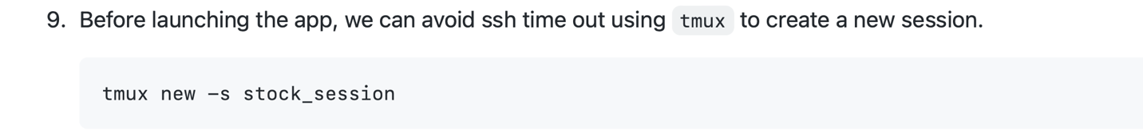

tmux new -s stock_session

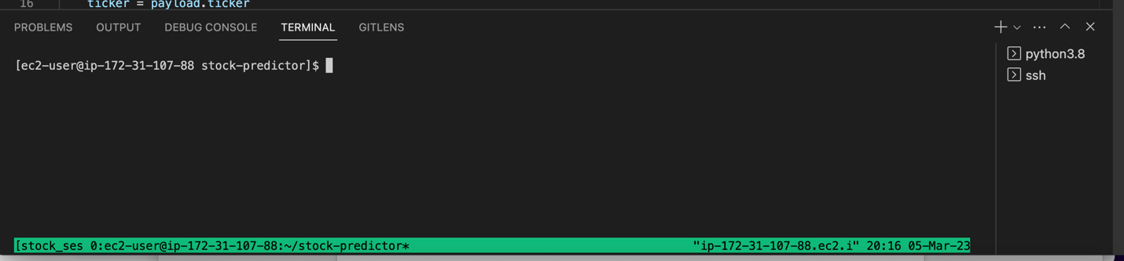

[ec2-user@ip-172-31-107-88 stock-predictor]$ ls

AJG.joblib AJG_plot.png LICENSE model.py MSFT_plot_components.png NEWfile.py README.md

AJG_plot_components.png gilou.pem main.py MSFT.joblib MSFT_plot.png __pycache__ requirements.txt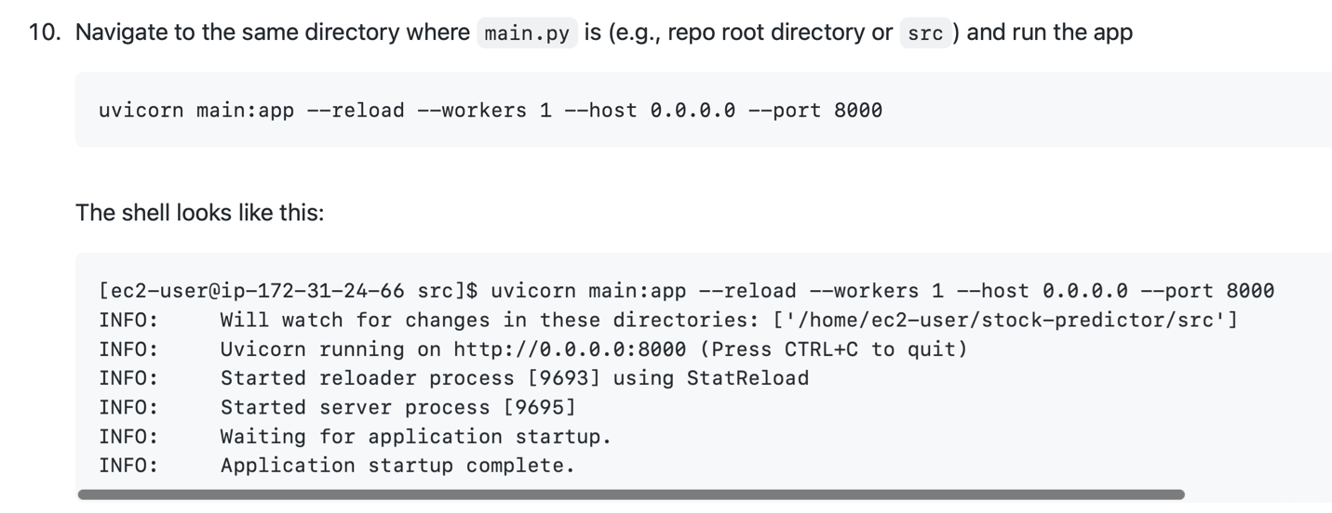

[ec2-user@ip-172-31-107-88 stock-predictor]$ uvicorn main:app --reload --workers 1 --host 0.0.0.0 --port 8000

INFO: Will watch for changes in these directories: ['/home/ec2-user/stock-predictor']

INFO: Uvicorn running on http://0.0.0.0:8000 (Press CTRL+C to quit)

INFO: Started reloader process [3693] using StatReload

INFO: Started server process [3695]

INFO: Waiting for application startup.

INFO: Application startup complete.

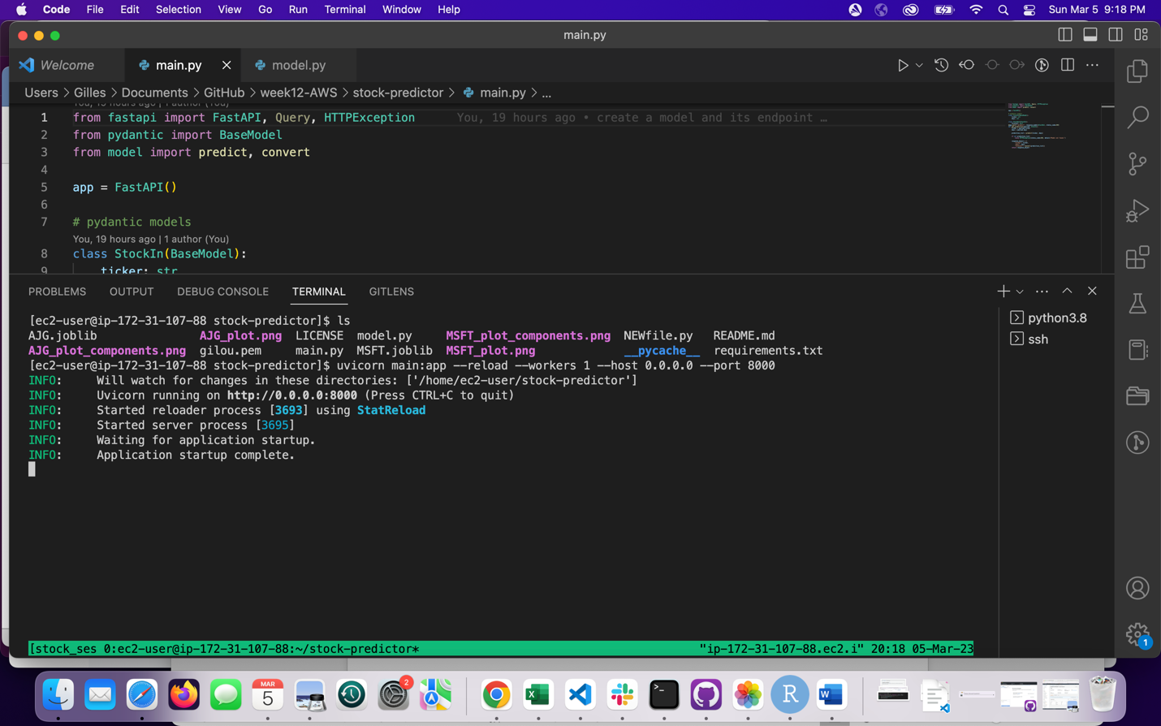

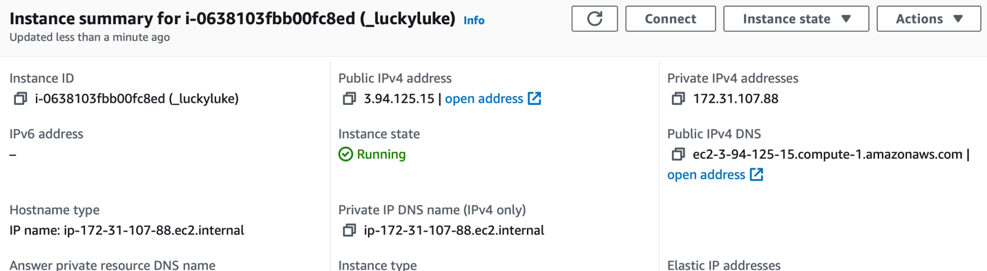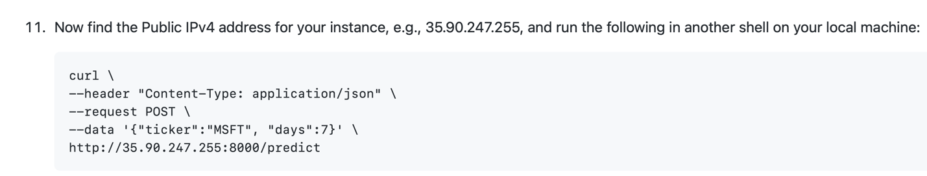

3.94.125.15

curl \

--header "Content-Type: application/json" \

--request POST \

--data '{"ticker":"MSFT", "days":7}' \

<http://3.94.125.15:8000/predict>

{"ticker":"MSFT","days":7,"forecast":{"03/06/2023":244.83054811717994,"03/07/2023":244.8113671133644,"03/08/2023":244.79218610954882,"03/09/2023":244.7730051057333,"03/10/2023":244.7538241019177,"03/11/2023":244.7346430981021,"03/12/2023":244.71546209428655}}%

(stock-predictor) Gilles@patricias-macbook-pro-2 stock-predictor %

FastAPI works on the web:

<http://3.94.125.15:8000/docs#/default/get_prediction_predict_post>

curl: (28) Failed to connect to 3.94.125.15 port 80 after 75018 ms: Operation timed out (forgot 8000)

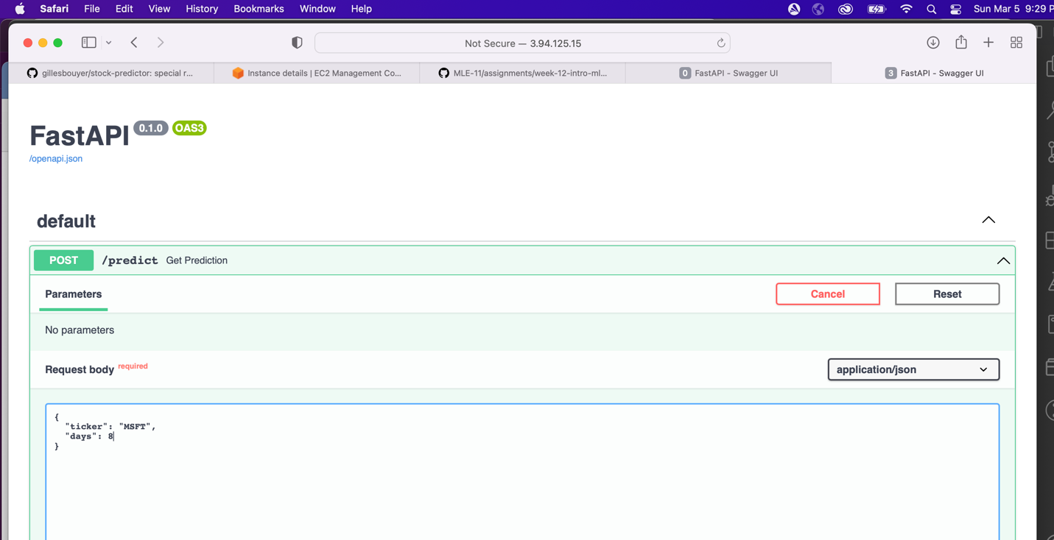

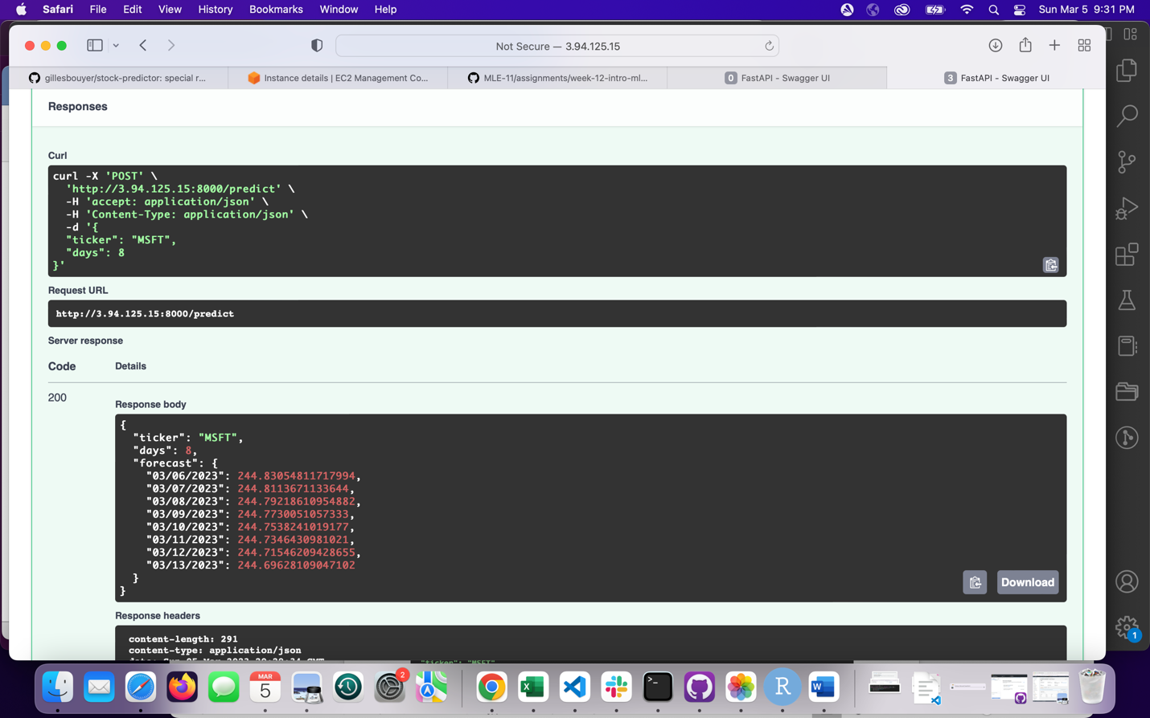

**curl -X 'POST' \**

**'http://3.94.125.15:8000/predict' \**

**-H 'accept: application/json' \**

**-H 'Content-Type: application/json' \**

**-d '{**

**"ticker": "MSFT",**

**"days": 8**

**}'**

curl -X 'POST' \

'http://3.94.125.15:8000/predict' \

-H 'accept: application/json' \

-H 'Content-Type: application/json' \

-d '{

"ticker": "MSFT",

"days": 8

}'

{"ticker":"MSFT","days":8,"forecast":{"03/06/2023":244.83054811717994,"03/07/2023":244.8113671133644,"03/08/2023":244.79218610954882,"03/09/2023":244.7730051057333,"03/10/2023":244.7538241019177,"03/11/2023":244.7346430981021,"03/12/2023":244.71546209428655,"03/13/2023":244.69628109047102}}%

(stock-predictor) Gilles@patricias-macbook-pro-2 stock-predictor %

Final step: detach tmux session so that it continues running in the background when you leave ssh shell. Press Ctrl+b, release, then press d (NOT Ctrl, b, and d together). Then you can leave the ssh shell and the app will continue running.